CSS BRITISH HISTORY · TOPIC 6 · QUESTION ANSWERS
Victorian Britain and the World (1815–1907)
Every past question on Palmerston, the Eastern Question, the Crimean War, Disraeli and Gladstone, and Splendid Isolation — answered in full, in simple words, with answer maps


All 11 past items (2015–2026): ten full answers and one short note; the four past MCQs solved; five predicted questions with outlines.
Topic 6 of 10 · companion to T6KB (the Knowledge Base)
Contents
HOW TO USE THIS · Updating the contents
Right-click the contents → Update Field → Update entire table, before saving as PDF.

How to Use These Answers 7
Answer 1 · Palmerston: Radical and Jingo, Neither Whig nor Tory 8
The model answer 9
Introduction 9
(1) Understanding the four labels 9
(2) His political journey 9
(3) Palmerston the Radical 9
(4) Palmerston the Jingo 10
(5) Why he was not, at heart, a Whig 10
(6) Why he was not, at heart, a Tory 10
(7) What was he "at heart"? 10
Answer 2 · Palmerston: Conservative at Home, Liberal Abroad 12
The model answer 13
Introduction 13
(1) Background: who was Palmerston? 13
(2) Conservative at home — the evidence 13
(3) The limits of his conservatism 13
(4) Liberal abroad — the evidence 13
(5) The limits of his liberalism abroad 14
(6) Explaining the contrast 14
Answer 3 · Palmerston: Foreign Minister or Prime Minister? 16
The model answer 17
Introduction 17
Palmerston as Foreign Secretary 17
(1) Successes 17
(2) Failures 18
Palmerston as Prime Minister 18
(3) Successes 18
(4) Failures 18
(5) Comparing the two 19
(6) Critical analysis — reasons for the difference 19
Answer 4 · The Eastern Question and England's Attitude, 1820–1913 20
The model answer 21
Introduction 21
Limb 1 · Explaining the Eastern Question 22
(1) The decline of the Ottoman Empire 22
(2) The interests of the powers 22
(3) Why it was dangerous 22
Limb 2 · England's attitude, 1820–1913 22
(4) Phase 1 · 1820–1841: preserving Turkey against Russia, France and Egypt 22
(5) Phase 2 · 1853–1856: war to preserve Turkey 22
(6) Phase 3 · 1856–1878: preserving Turkey, but a divided nation 23
(7) Phase 4 · 1878–1907: Egypt replaces Constantinople 23
(8) Phase 5 · 1908–1913: mediator in the last crises 23
(9) Critical analysis 24
Answer 5 · The Crimean War: Background and Results 25
The model answer 26
Introduction 26
Limb 1 · The background 27
(1) The long-term background 27
(2) The immediate background, 1852–1854 27
(3) The war in brief 28
Limb 2 · The results 28
(4) The Treaty of Paris (30 March 1856) 28
(5) The results for the Eastern Question 28
(6) The results for Europe — the most important 29
(7) The results for Britain 29
(8) The results for Russia 29
(9) Analysis — was the war worth it? 29
Short Note 31
The Treaty of Berlin (1878) 31
Answer 6 · Gladstone and Disraeli: Characters and Policies, Especially in Foreign Affairs 32
The model answer 33
Introduction 33
The characters 33
(1) Disraeli (1804–81) 33
(2) Gladstone (1809–98) 33
The policies — foreign affairs 34
(3) Disraeli's foreign and imperial policy (1874–80) 34
(4) Gladstone's principles 35
(5) Gladstone's foreign policy in practice 35
(6) Domestic policy — briefly 35
Analysis 36
(7) How character shaped policy 36
(8) The paradox of office 36
Answer 7 · Disraeli's Policy and "Peace with Honour" 37
The model answer 38
Introduction 38
(1) Disraeli's aims 38
(2) Imperial measures 38
(3) The Eastern crisis, 1875–77 38
(4) Britain's response — the threat of war 38
(5) San Stefano (3 March 1878) 39
(6) Preparing the Congress 39
(7) The Congress of Berlin (13 June – 13 July 1878) 39
(8) Was it "Peace with Honour"? — the case for 39
(9) The case against 40
Answer 8 · Splendid Isolation: Why Adopted, How Abandoned 41
The model answer 42
Introduction 42
(1) What Splendid Isolation meant 42
Limb 1 · Why Britain adopted it from 1870 43
(2) Security: an island and a navy 43
(3) Global interests 43
(4) The European balance after 1870 43
(5) Economic and imperial strength 43
(6) Politics and public opinion 43
(7) Confidence 43
Limb 2 · How the policy was abandoned 44
(8) Why isolation became dangerous (1890–1902) 44
(9) Step 1 · Failed approaches to Germany (1898–1901) 44
(10) Step 2 · Friendship with the USA 44
(11) Step 3 · The Anglo-Japanese Alliance (30 January 1902) 44
(12) Step 4 · The Entente Cordiale (8 April 1904) 44
(13) Step 5 · The Anglo-Russian Convention (31 August 1907) 45
(14) Analysis 45
Answer 9 · How Britain Halted Splendid Isolation — Its Positive and Negative Aspects 46
The model answer 47
Introduction 47
Limb 1 · How Britain put a halt to isolation 47
(1) The pressures that forced a change 47
(2) The first attempt: Germany (1898–1901) 47
(3) Step 1 · The Anglo-Japanese Alliance (1902) 47
(4) Step 2 · The Entente Cordiale (1904) 48
(5) Step 3 · The Anglo-Russian Convention (1907) 48
(6) Also: friendship with the USA 48
Limb 2 · Positive and negative aspects of Splendid Isolation 48
(7) Positive aspects 48
(8) Negative aspects 49
(9) Positive and negative results of ending it 49
Answer 10 · Splendid Isolation: Why It Began, and Was It Right? 50
The model answer 51
Introduction 51
Limb 1 · Why Britain initiated the policy 51
(1) Geography and sea power 51
(2) Economic and imperial strength 51
(3) The European situation after 1870 51
(4) Freedom of action 51
(5) Lessons of the past 51
Limb 2 · My opinion — right step or detrimental? 52
(6) Why I think it was a right step (c.1870–1895) 52
(7) Why I think it became detrimental (c.1895–1902) 52
(8) Considering the opposite view 52
(9) My judgement 52
Part Two — The Past MCQs, Solved 54
CSS 2024 · MCQ 2 54
CSS 2024 · MCQ 3 54
CSS 2024 · MCQ 17 54
CSS 2026 · MCQ 17 54
Part Three — Five Predicted Questions, with Outlines 56
Predicted 1 · "Compare the foreign policies of Castlereagh and Canning." 56
Predicted 2 · "Discuss the causes of the Scramble for Africa and Britain's role in it." 56
Predicted 3 · "Examine the causes and consequences of the Boer War (1899–1902)." 56
Predicted 4 · "Discuss the causes and results of the Indian Mutiny of 1857." 57
Predicted 5 · "Trace British policy towards Egypt and the Sudan from 1875 to 1904." 57

How to Use These Answers
# | Paper | Question (short) | Answer
1 | 2015 P-I Q7 | Palmerston: "Radical and Jingo, but at heart neither Whig nor Tory" | Answer 1
2 | 2015 P-II Q2 | Palmerston: conservative at home, liberal abroad | Answer 2
3 | 2016 Q4 | Palmerston: more successful as Foreign Minister than as PM | Answer 3
4 | 2017 Q6 | The Eastern Question; England's attitude 1820–1913 | Answer 4
5 | 2015 P-II Q5 | The Crimean War: background and results | Answer 5
6 | 2016 Q8(b) | Short note: the Treaty of Berlin | Short note
7 | 2015 P-II Q4 | Gladstone and Disraeli: characters and policies, esp. foreign | Answer 6
8 | 2016 Q5 | Disraeli's policy and "Peace with Honour" | Answer 7
9 | 2015 P-II Q7 | Splendid Isolation: why adopted, how abandoned | Answer 8
10 | 2018 Q6 | How isolation was halted; its positive and negative aspects | Answer 9
11 | 2023 Q4 | Why isolation; your opinion — right or detrimental? | Answer 10

Every answer has: the question as set · its answer map · decoding the question (what the examiner wants, in plain words) · a model answer with numbered headings, figures and a verdict · why this answer scores.
TRAP — DO NOT FALL INTO IT · Three Palmerston questions, three Isolation questions — never the same answer
Palmerston: 2015 asks what he was (labels), 2015 again asks about home v abroad, 2016 about Foreign Secretary v Prime Minister. Splendid Isolation: 2015 asks why and how abandoned, 2018 how halted and its merits, 2023 why and your opinion. The facts are the same (T6KB Chapters 2 and 7); the headings must come from each question's own words.

HOW TO USE THIS · If you are new to this topic
Read T6KB Part Zero first — above all Britain's five interests (0.3). Nearly every answer below is built on them. Every hard word is explained again inside the answers.

Answer 1 · Palmerston: Radical and Jingo, Neither Whig nor Tory
THE QUESTION · CSS 2015 · Q7 · Paper I · 20 marks
'Palmerston was at once a Radical and Jingo, but at heart neither a Whig nor a Tory.' Elucidate.

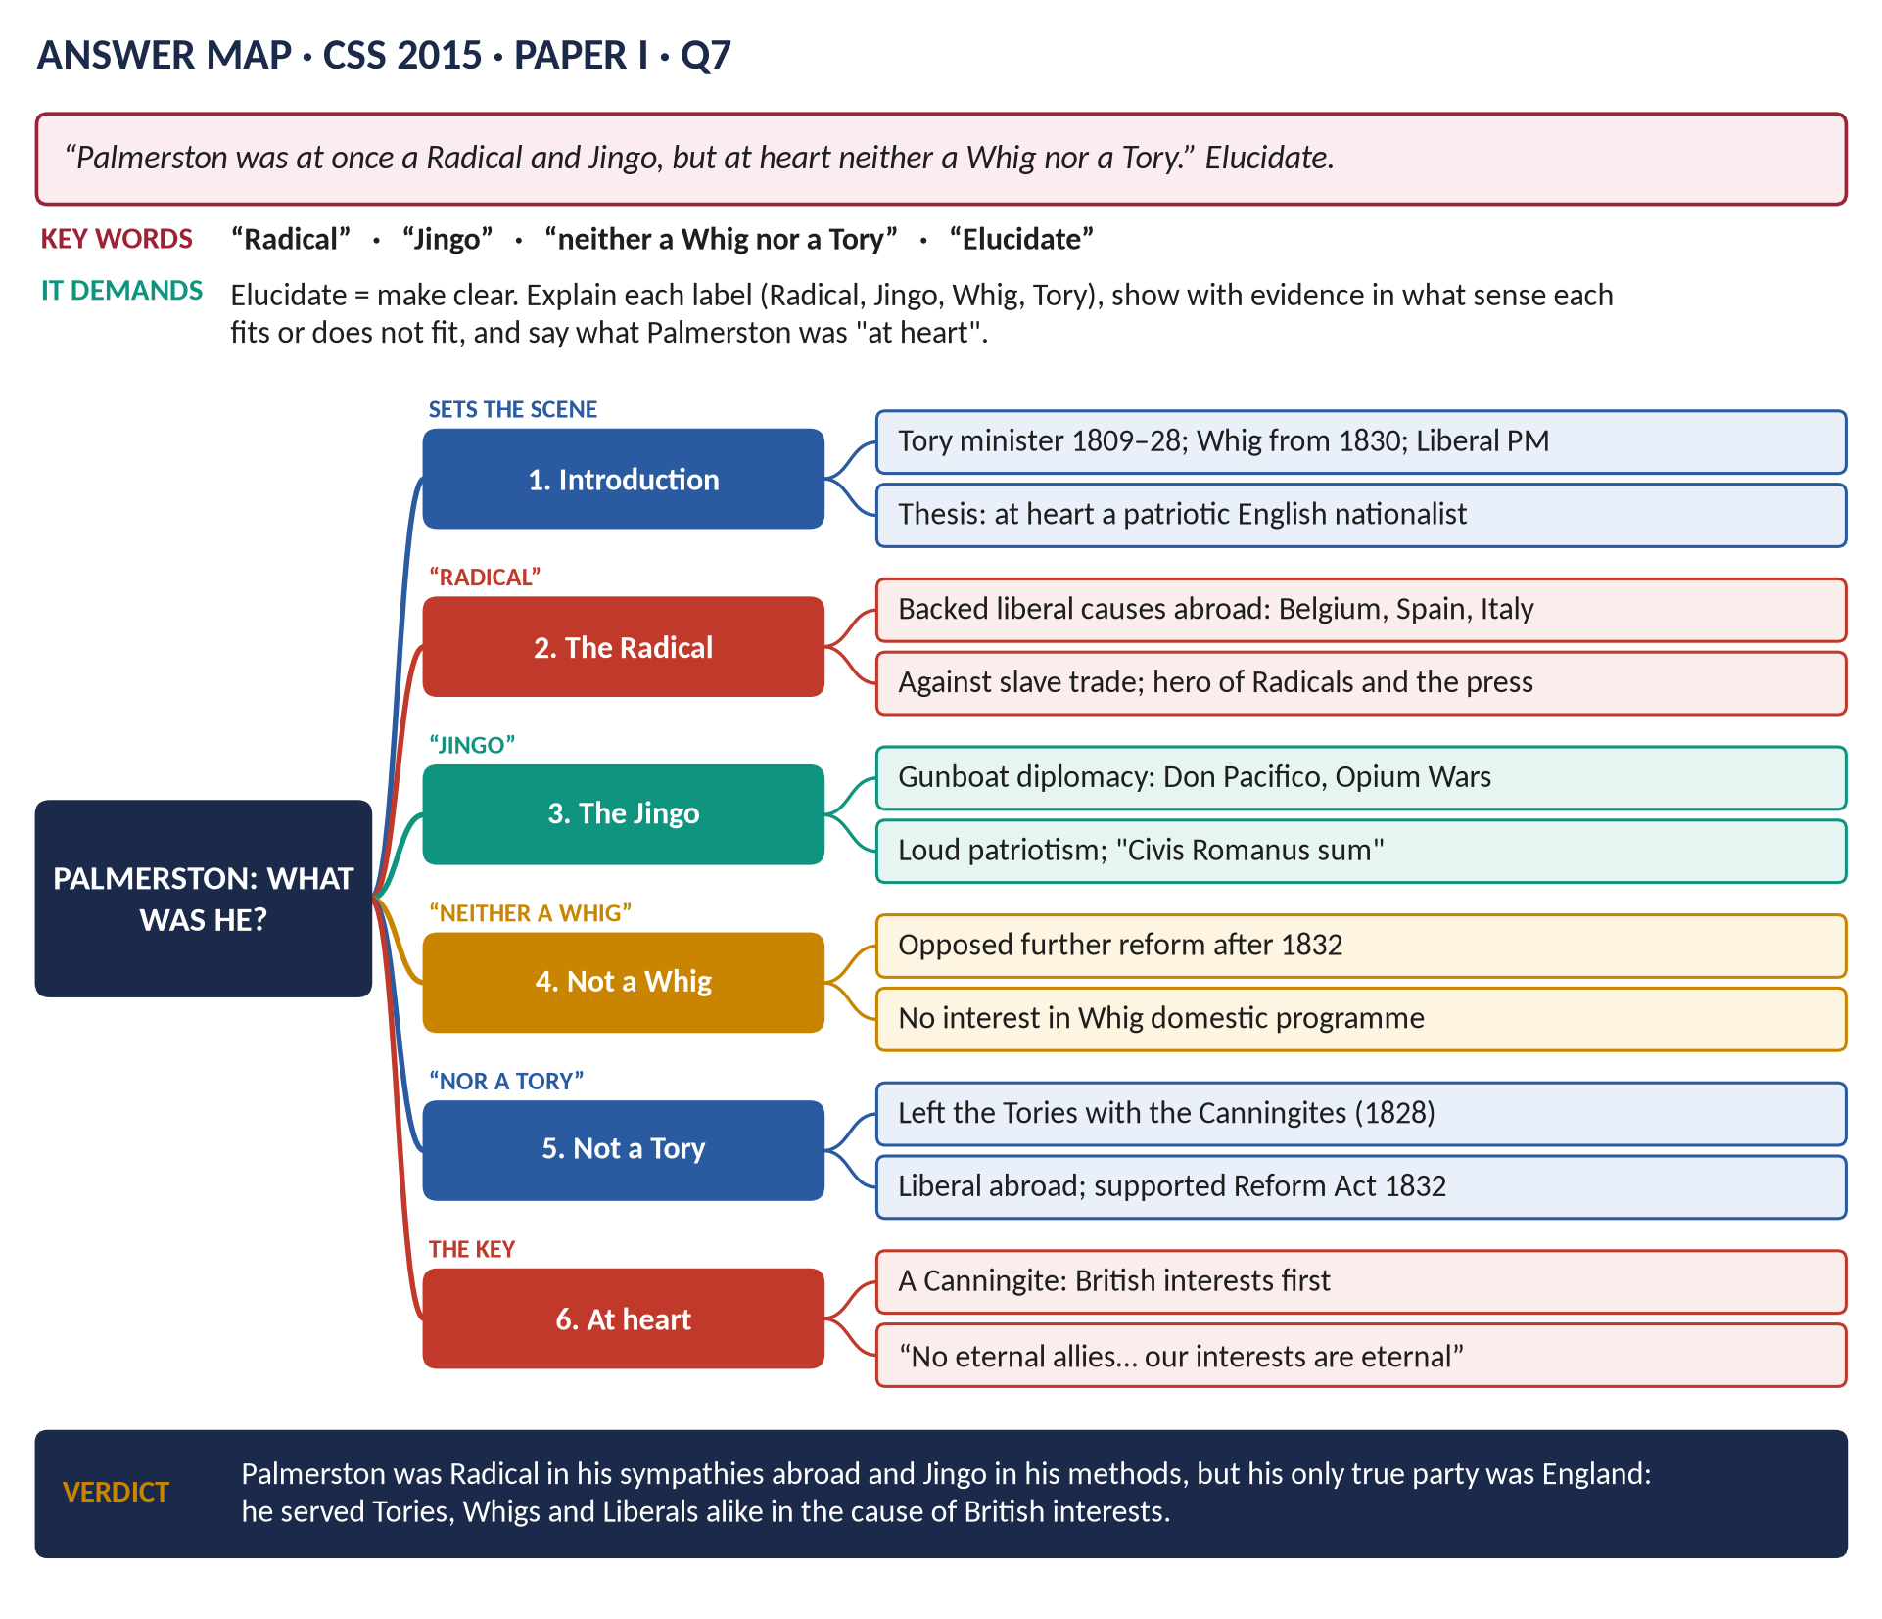
Figure 1 · The answer map for CSS 2015 · Q7 · Paper I: every branch is one heading of the answer below.
DECODING THE QUESTION
"Elucidate" = make clear, explain. The statement uses four labels. Radical = someone who wanted big liberal change. Jingo = a loud, aggressive patriot (from a song of 1878). Whig and Tory = the two old parties. So: explain in what sense Palmerston was Radical, in what sense Jingo, why he was not really a Whig, why he was not really a Tory, and what he was "at heart".

The model answer

Introduction
Lord Palmerston (1784–1865) was the most famous British statesman of the mid-nineteenth century: Foreign Secretary for most of 1830–51 and Prime Minister for most of 1855–65. Yet he is hard to place in a party. He began as a minister in Tory governments, served the Whigs for twenty years and became the first leader of the Liberal Party. The statement that he was "at once a Radical and Jingo, but at heart neither a Whig nor a Tory" is a clever summary. This answer argues that it is largely correct: his sympathies abroad were Radical, his methods were Jingo, and his real loyalty was to neither party but to British interests and prestige — he was, at heart, a Canningite patriot.

(1) Understanding the four labels
Label | Meaning in the 19th century
Radical | A reformer who wanted wide change: democracy, religious equality, support for liberal and national movements abroad.
Jingo | A loud, aggressive patriot who likes to threaten force — from the 1878 music-hall song "by Jingo". (The word came after Palmerston, but it describes him well.)
Whig | The aristocratic reforming party: parliamentary and religious reform at home, cautious liberalism.
Tory | The party of the Crown, the Church, the landed interest and order; hostile to reform.

(2) His political journey
- 1807–28: a Tory minister — for almost twenty years Secretary at War, an administrative post, taking little part in great debates.
- 1828: he left Wellington's government with the Canningites — the liberal followers of Canning.
- 1830: he joined Grey's Whig government as Foreign Secretary.
- 1859: he became the first Prime Minister of the new Liberal Party.
This journey itself shows that party labels meant little to him.

(3) Palmerston the Radical
In foreign affairs, Palmerston took the side Radicals liked:
1. Belgium (1830–39): he helped the Belgians win independence from the Dutch king.
2. Spain and Portugal (1834): his Quadruple Alliance backed the liberal constitutional queens against absolutist pretenders.
3. 1848–50: he welcomed the liberal revolutions, protected the Hungarian leader Kossuth and other refugees in Turkey against Austria and Russia, and praised the workers who attacked the brutal Austrian general Haynau.
4. Italy (1859–60): as Prime Minister he supported Italian unification.
5. The slave trade: he used the navy to hunt slave ships and forced treaties on other nations.
6. Public opinion: like the Radicals, he appealed to the press and the people over the heads of the Court and the aristocracy. Radical newspapers cheered him, and the Court and the conservative powers of Europe hated him.

(4) Palmerston the Jingo
His methods were those of an aggressive patriot:
1. Gunboat diplomacy: the navy blockaded Greece over the Don Pacifico affair (1850).
2. "Civis Romanus sum": in his famous speech he said that a British subject, like a Roman citizen, should be protected by "the watchful eye and the strong arm of England" anywhere in the world.
3. Wars against China: the Opium War (1839–42) and the Arrow War (1856–60), fought to force trade on China.
4. Threats and bluster: against France in 1840, against the USA over the Trent (1861), and — without any power to act — against Prussia over Denmark (1864).
5. Popular nationalism: he was the idol of the music halls and the popular press — a model for later jingoism.

(5) Why he was not, at heart, a Whig
- The Whigs' great cause was domestic reform — Parliament, the Church, the law. Palmerston cared little for it.
- He accepted the 1832 Reform Act but then opposed further reform; as Prime Minister (1859–65) he blocked it: "there is really nothing to be done".
- He did not share the Whig aristocrats' caution abroad — his colleagues (and the Queen) often thought him reckless.

(6) Why he was not, at heart, a Tory
- He left the Tories in 1828.
- He supported Catholic Emancipation and the Reform Act of 1832 — both opposed by most Tories.
- His support for liberal movements abroad was the opposite of the Tory tradition of supporting established monarchs.
- The Conservatives under Derby and Disraeli were his opponents for the last twenty years of his life.

(7) What was he "at heart"?
- A Canningite: like Canning, he put British interests first, supported liberal causes when they helped Britain, and appealed to public opinion.
- A patriot above party: "We have no eternal allies, and we have no perpetual enemies. Our interests are eternal and perpetual, and those interests it is our duty to follow" (1848).
- Conservative at home: in domestic matters his instincts were those of an eighteenth-century aristocrat — which is why some called him "a Tory at home".
KEY IDEA · The paradox resolved
Palmerston's Radicalism and his Jingoism were two sides of one thing: English nationalism. He backed liberal causes because liberal states were Britain's natural friends, and he used force because he believed British power should be felt. Neither party label captures this; "patriot" does.

VERDICT · Conclusion
The statement is accurate. Palmerston was Radical in his sympathy for liberal and national movements abroad and in his appeal to public opinion; he was Jingo in his gunboats and his boasting of British power. But he was neither a true Whig, since he cared nothing for domestic reform, nor a true Tory, since he had left the Tories and backed liberalism abroad. At heart he belonged to no party: he was a patriotic statesman whose only fixed principle was the interest and prestige of England.

WHY THIS ANSWER SCORES · Why this answer scores
It defines all four labels (a table) · it tests each label with numbered evidence · it shows his party journey as proof · it explains what he was "at heart" — the phrase most answers ignore — with the key quotation · the key box reconciles Radical and Jingo into one idea.

Answer 2 · Palmerston: Conservative at Home, Liberal Abroad
THE QUESTION · CSS 2015 · Q2 · Paper II · 20 marks
Palmerston was conservative at home and liberal abroad. Discuss and conclude with arguments.

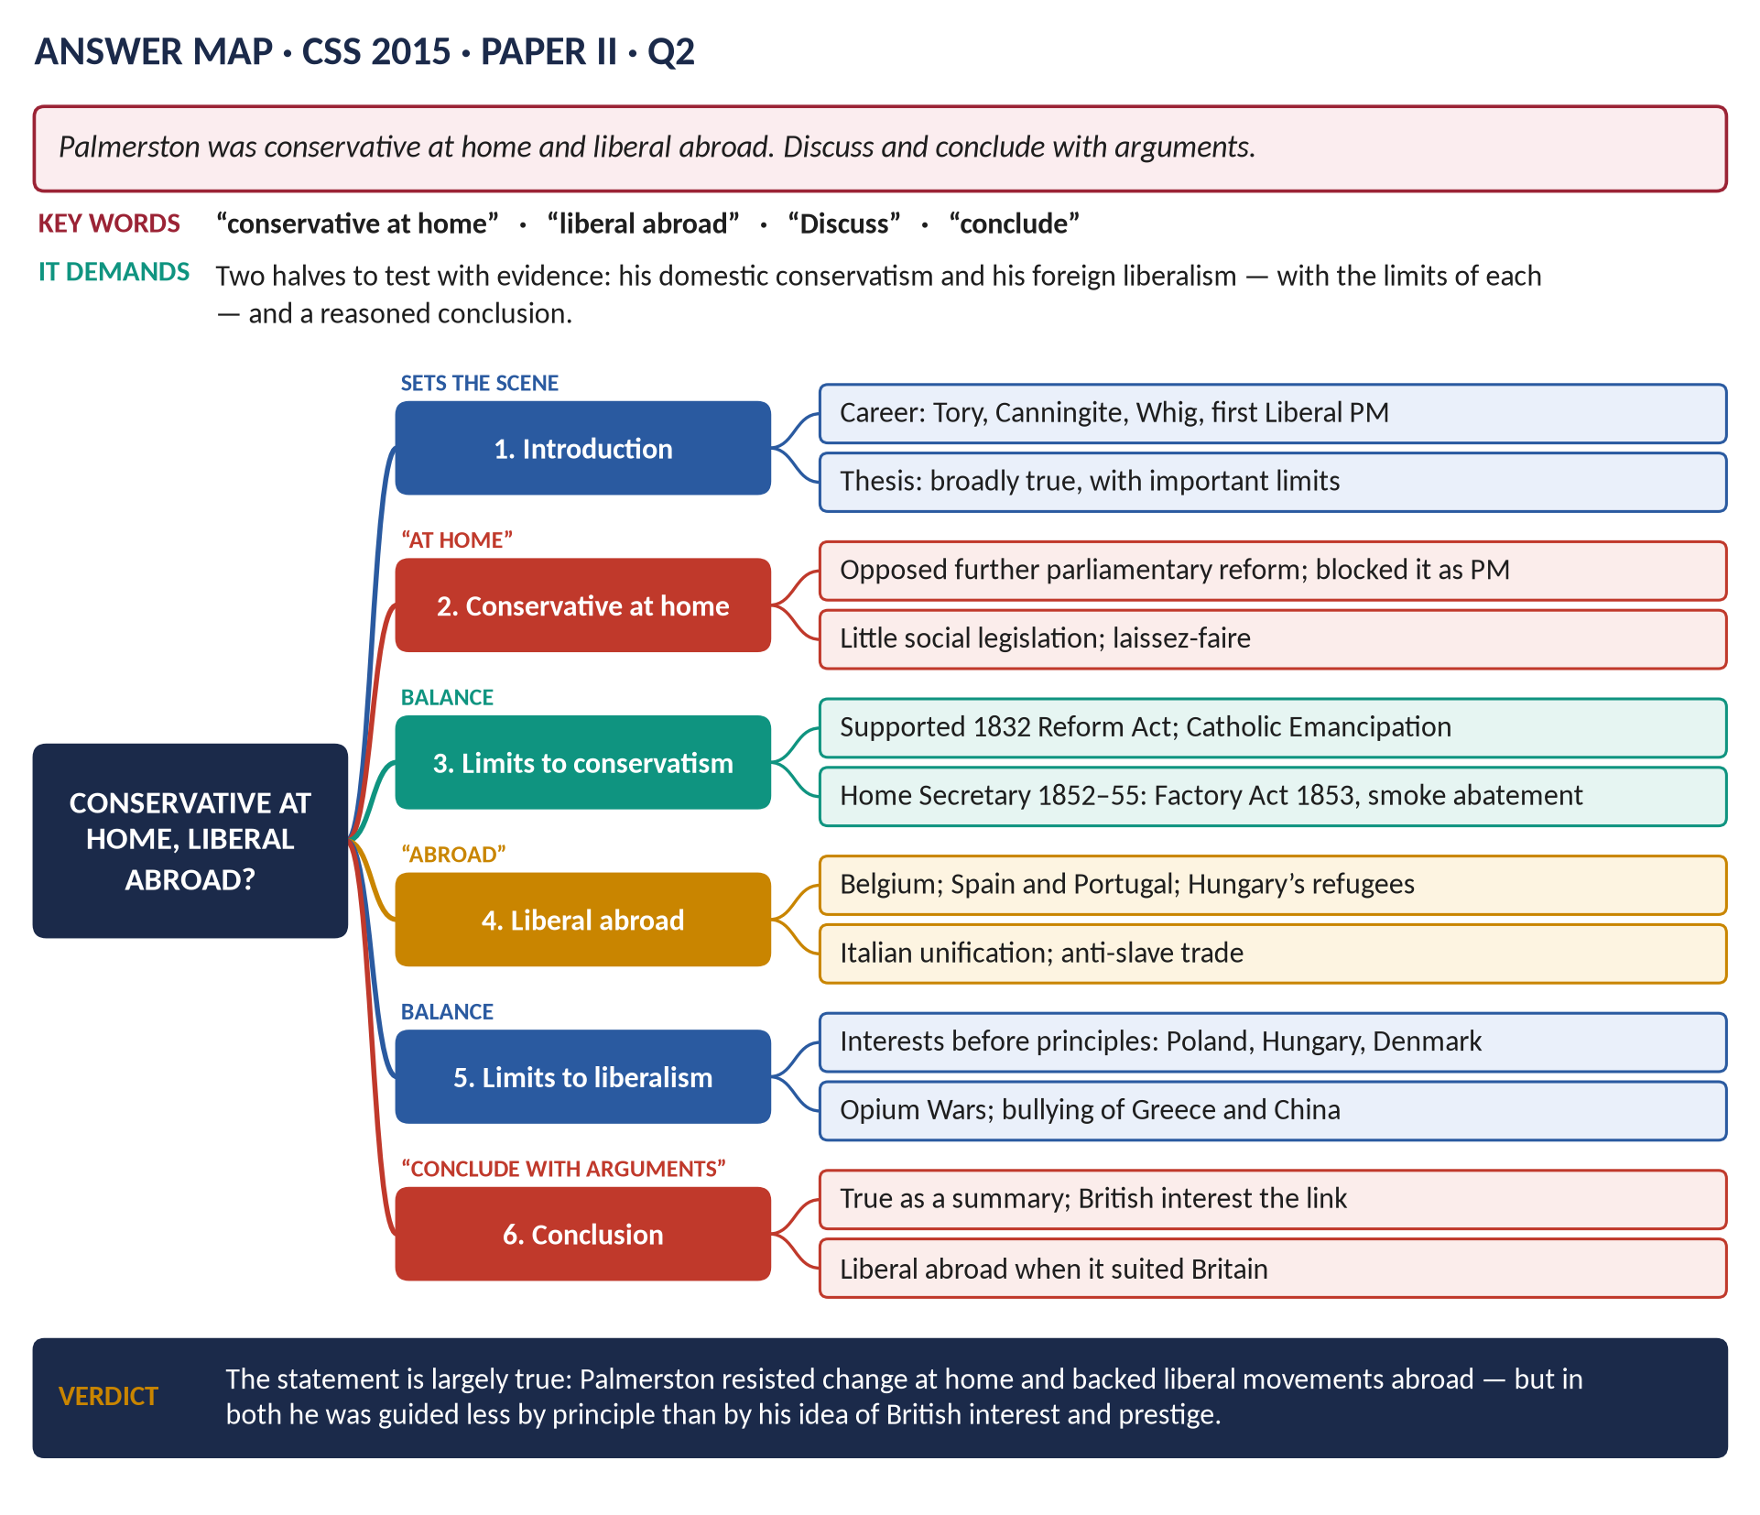
Figure 2 · The answer map for CSS 2015 · Q2 · Paper II: every branch is one heading of the answer below.
DECODING THE QUESTION
"Discuss and conclude with arguments" = examine both halves of the statement with evidence, show the limits of each, and end with a firm conclusion. Conservative at home = resisting change in British domestic affairs. Liberal abroad = supporting liberal (constitutional, national, free) movements in other countries. Don't narrate his whole career — organise by the two halves.

The model answer

Introduction
It was often said of Lord Palmerston that he was "a Conservative at home and a Liberal abroad". At home he opposed further parliamentary reform and passed little social legislation; abroad he supported constitutional governments and national movements against the conservative monarchies of Europe. This answer argues that the statement is broadly true, but that both halves have limits — and that the link between them was not ideology but his view of British interest.

(1) Background: who was Palmerston?
Tory minister (1807–28); Canningite; Whig Foreign Secretary (1830–41, 1846–51); Home Secretary (1852–55); Prime Minister (1855–58, 1859–65), first leader of the Liberal Party.

(2) Conservative at home — the evidence
1. Parliamentary reform: after accepting the 1832 Act, he opposed further extension of the vote. As Prime Minister he quietly shelved Russell's reform bills (1854, 1860). Reform came only after his death (1867).
2. Little legislation: his governments of 1859–65 passed almost no major domestic reform; he believed that government should interfere as little as possible (laissez-faire).
3. Social attitudes: an Irish landlord and aristocrat, he defended property, the Church of England and the existing constitution.
4. Trade unions and democracy: he distrusted popular movements at home, even while praising them abroad.
5. Disraeli remarked that the Conservatives had no need to take office while Palmerston was Prime Minister — he was doing their work.

(3) The limits of his conservatism
1. He supported Catholic Emancipation (1829) and the Reform Act (1832).
2. As Home Secretary (1852–55) he was an active reformer: the Factory Act of 1853 (limiting children's hours), the Smoke Abatement Act, reform of prisons, the ending of transportation of convicts to most colonies, and vaccination.
3. His government accepted Gladstone's free-trade budgets (1860) and the Divorce Act (1857).

(4) Liberal abroad — the evidence
1. Belgium (1830–39): supported the Belgian revolt; guaranteed its independence and neutrality (1839).
2. The Quadruple Alliance (1834): backed constitutional governments in Spain and Portugal against absolutist pretenders.
3. Greece: supported the young constitutional kingdom (though he also bullied it).
4. 1848–49: sympathy with the revolutions; protection of Hungarian and Polish refugees in Turkey.
5. Italy (1859–60): diplomatic support for Italian unification — perhaps his most liberal act.
6. The slave trade: a lifelong campaign to suppress it.
7. Opposition to the Holy Alliance: he saw Britain as the leader of the "liberal West" against the absolutist East (Russia, Austria, Prussia).

(5) The limits of his liberalism abroad
1. Interests before principles: he did nothing for the Hungarians in 1849 (Austria was needed to balance Russia), the Poles in 1863, or the Danes in 1864.
2. Turkey: he propped up the despotic Ottoman Empire because it guarded the route to India.
3. China: the Opium Wars forced a drug trade on a weaker country — hardly liberal.
4. Gunboat diplomacy: the blockade of Greece over Don Pacifico (1850) bullied a small state.
5. Napoleon III: he welcomed the French coup of 1851 — the end of a republic — because a strong France under Louis Napoleon suited Britain.
 | Evidence for the statement | Evidence against
At home | Blocked reform 1859–65; laissez-faire; landlord outlook | Emancipation 1829; Reform Act 1832; Home Office reforms 1853–55
Abroad | Belgium, Spain, Portugal, Italy, refugees, anti-slavery | Poland, Hungary, Denmark abandoned; Turkey propped up; Opium Wars

(6) Explaining the contrast
- At home, Britain already had the constitutional government he admired; he saw no need for more change, which might endanger property and order.
- Abroad, liberal constitutional states were likely to be friendly to Britain, to trade with it, and to balance the absolutist powers. Supporting them served British interests.
- So his "liberalism abroad" and "conservatism at home" came from the same root: British interest as he understood it.
VERDICT · Conclusion
The statement is broadly true: Palmerston resisted domestic change, especially further reform of Parliament, while supporting liberal and constitutional movements in Belgium, Spain, Portugal and Italy. But both halves need qualifying — he had been a useful reforming Home Secretary, and abroad his liberalism stopped wherever British interests stopped, as the Poles, Hungarians and Danes discovered. He was, above all, a pragmatic patriot: liberal abroad when it suited Britain, conservative at home because Britain, in his view, was already the best-governed country in the world.

WHY THIS ANSWER SCORES · Why this answer scores
Organised by the two halves, each with evidence and limits · a for-and-against table · an explanation of why the contrast existed · the conclusion answers "conclude with arguments" with a clear, reasoned view.

Answer 3 · Palmerston: Foreign Minister or Prime Minister?
THE QUESTION · CSS 2016 · Q4 · Section A · 20 marks
'Lord Palmerston was more successful as Foreign Minister than as Prime Minister.' Critically analyze.

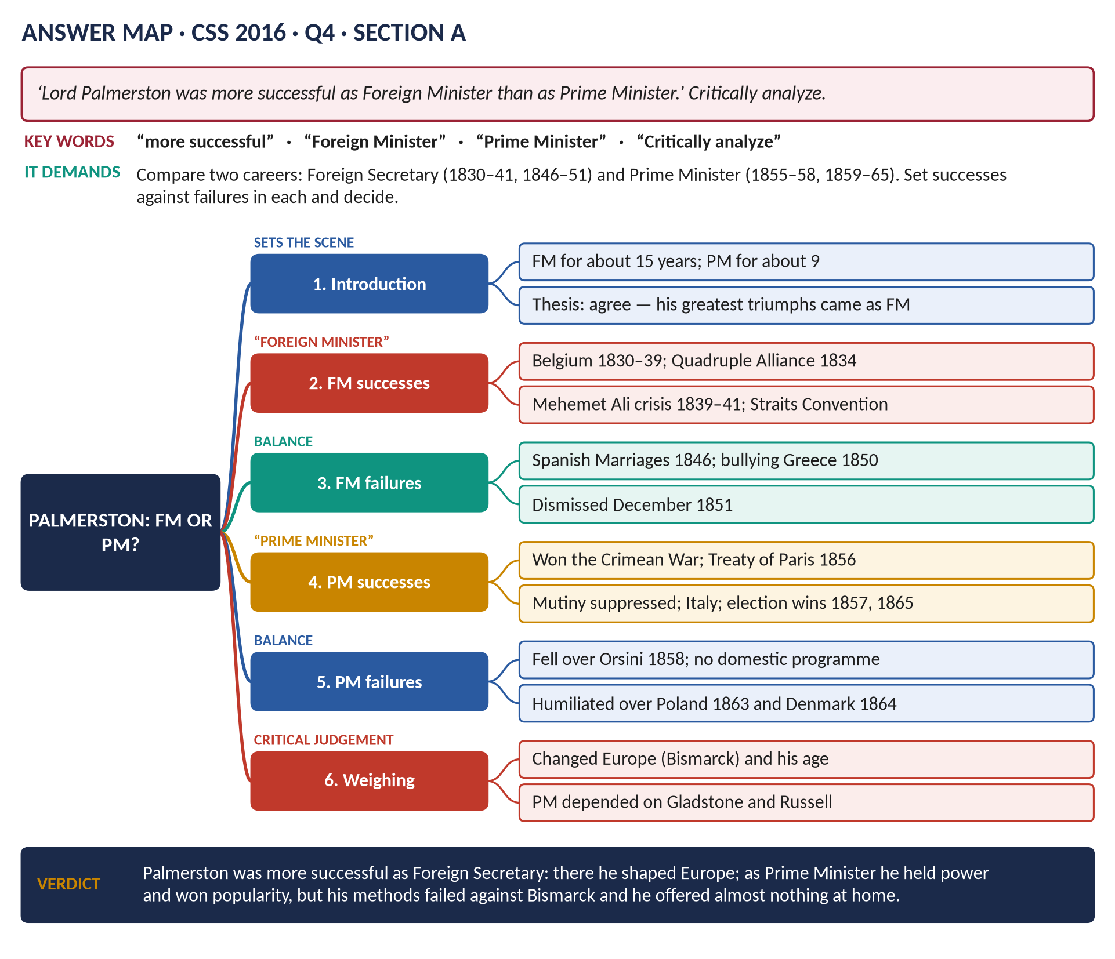
Figure 3 · The answer map for CSS 2016 · Q4 · Section A: every branch is one heading of the answer below.
DECODING THE QUESTION
"Critically analyze" = examine the statement from both sides and judge it. You must compare two careers: as Foreign Secretary (1830–34, 1835–41, 1846–51) and as Prime Minister (1855–58, 1859–65). Measure both by the same yardsticks — achievements, failures, lasting results — and decide. Remember a Prime Minister is judged on domestic policy too.

The model answer

Introduction
Lord Palmerston was Foreign Secretary for about fifteen years and Prime Minister for about nine. As Foreign Secretary he became the most famous diplomat in Europe; as Prime Minister he was the most popular politician in Britain. This answer argues that the statement is correct: Palmerston's greatest and most lasting achievements came at the Foreign Office, while as Prime Minister, though successful in keeping power, he was outplayed abroad by Bismarck and offered almost nothing at home.
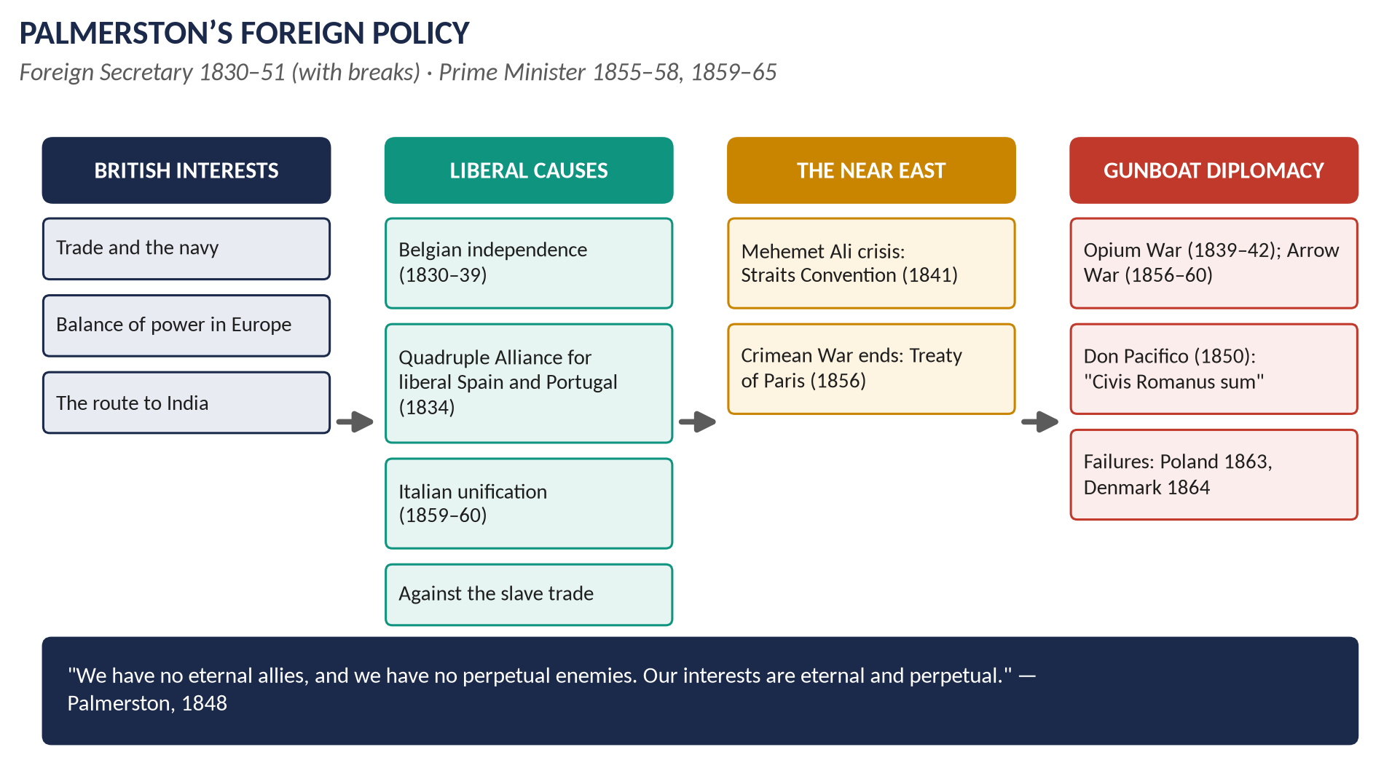
Figure 4 · Palmerston's foreign policy at a glance.

Palmerston as Foreign Secretary

(1) Successes

(a) Belgium (1830–39)
The Belgian revolt of 1830 could have let France take Belgium — a threat to Britain's coast. Palmerston worked through a London Conference, got Leopold made king, forced the French army out and the Dutch to accept, and secured the Treaty of London (1839) guaranteeing Belgian independence and neutrality — a settlement that lasted until 1914.

(b) The Quadruple Alliance (1834)
Britain, France, Spain and Portugal combined to support the liberal governments of Spain and Portugal — a "liberal West" to balance the conservative Eastern powers.

(c) The Mehemet Ali crises and the Straits (1839–41)
When the French-backed Mehemet Ali of Egypt threatened the Sultan, Palmerston built a coalition of Britain, Russia, Austria and Prussia, bombarded Acre, forced Mehemet Ali back to Egypt and isolated France. The Straits Convention (1841) closed the Straits to foreign warships in peacetime and cancelled Russia's special position (Unkiar Skelessi, 1833). Historians call this his masterpiece.

(d) China (1839–42)
The Opium War and the Treaty of Nanking (1842) gained Hong Kong and opened China to British trade — a success for British interests, though morally questionable.

(e) Popularity (1850)
His Don Pacifico speech ("Civis Romanus sum") won a Commons vote and made him a national hero.

(2) Failures
- The Spanish Marriages (1846): outwitted by Louis Philippe; the entente with France collapsed.
- Bullying: the blockade of Greece (1850) angered the other powers.
- Clashes with the Queen and colleagues: he sent dispatches without showing them; dismissed in December 1851.

Palmerston as Prime Minister

(3) Successes
1. The Crimean War (1855–56): he gave the war energy, and secured the Treaty of Paris (1856), which neutralised the Black Sea.
2. India: the Mutiny (1857) was suppressed; the Government of India Act (1858) transferred India to the Crown.
3. China: the Arrow War ended with the Convention of Peking (1860) and Kowloon.
4. Italy (1859–60): with Russell he supported Italian unification — a new friendly state.
5. The American Civil War: he kept Britain neutral and avoided war over the Trent (1861).
6. Political success: he won the elections of 1857, 1859 and 1865; he held the new Liberal Party together; he was hugely popular.

(4) Failures
1. The Orsini affair (1858): his Conspiracy to Murder Bill, to please Napoleon III, was seen as bowing to France; he was defeated and resigned.
2. Poland (1863): loud protests against Russia, no action.
3. Denmark (1864): he told Parliament Denmark would "not stand alone"; when Prussia and Austria attacked, Britain did nothing. Bismarck had called his bluff — "meddle and muddle".
4. Domestic policy: he blocked parliamentary reform and offered no programme; the main achievements (the 1860 budget) were Gladstone's.
5. An old man's methods: bluster and the navy did not work against Prussia, a great land power.

(5) Comparing the two
Yardstick | As Foreign Secretary | As Prime Minister
Lasting achievements | Belgium (to 1914); Straits Convention; Hong Kong | Treaty of Paris (broken by 1871); India Act 1858; Italy
Failures | Spanish Marriages; dismissal | Orsini; Poland; Denmark; no home programme
Europe | He shaped it | Bismarck shaped it
Popularity | Rising | At its peak — elections won

(6) Critical analysis — reasons for the difference
1. The times changed: in the 1830s–40s Britain faced weak or divided rivals; by the 1860s it faced Bismarck, who knew Britain had no army to send.
2. His methods aged: gunboats could coerce Greece or China but not Prussia.
3. Different jobs: a Prime Minister must lead at home, and Palmerston had no domestic interests.
4. Age: he became PM at 70 and died in office at 80.
5. But as PM he achieved much that a Foreign Secretary could not: winning the Crimean War, holding power, and making the Liberal Party.
VERDICT · Conclusion
The statement is correct. As Foreign Secretary, Palmerston created lasting settlements — Belgium, the Straits Convention — and made Britain's influence felt throughout Europe and Asia. As Prime Minister he won a war, several elections and great popularity, but his methods failed against Bismarck in 1864, he fell over Orsini in 1858, and he had no domestic policy. His true greatness lay at the Foreign Office.

WHY THIS ANSWER SCORES · Why this answer scores
Two careers judged by the same yardsticks · successes and failures in each, with dates · a comparison table · a critical analysis of why he did better as FM · a clear verdict with a note of balance.

Answer 4 · The Eastern Question and England's Attitude, 1820–1913
THE QUESTION · CSS 2017 · Q6 · Section B · 20 marks
Explain the Eastern Question and critically analyse the attitude of England towards this question from 1820 to 1913.

Figure 5 · The answer map for CSS 2017 · Q6 · Section B: every branch is one heading of the answer below.
DECODING THE QUESTION
Two limbs. (1) "Explain the Eastern Question" — define it, explain why Turkey was declining, and what each Great Power wanted. (2) "Critically analyse the attitude of England towards this question from 1820 to 1913" — how Britain's policy changed over almost a century, why, and whether it was wise. A phase-by-phase structure is the clearest way to cover 93 years.

The model answer

Introduction
The Eastern Question was the great diplomatic problem of the nineteenth century: what should happen to the declining Ottoman (Turkish) Empire, and how the rivalry of the Great Powers over its lands — especially the Balkans and the Straits — could be managed without a general war. England's attitude was shaped by one constant aim: to keep Russia away from the Straits and the Mediterranean and so protect the route to India. Its methods, however, changed completely: from propping up Turkey (1820–78), to relying on Egypt and the Suez Canal (after 1882), to agreement with Russia (1907).
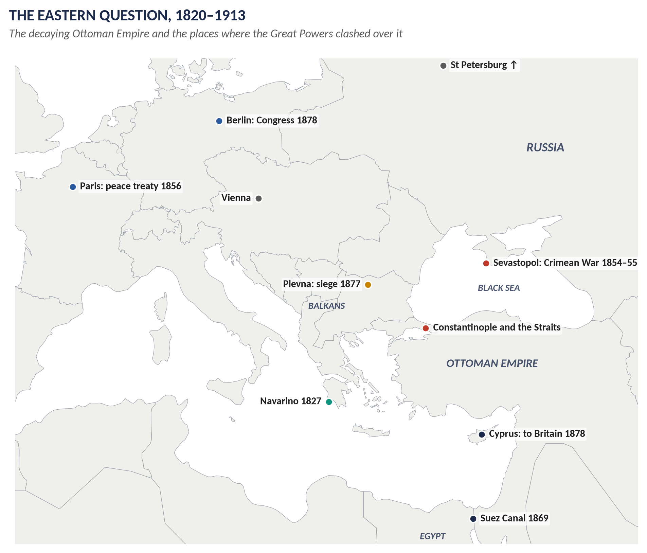
Figure 6 · The stage of the Eastern Question.

Limb 1 · Explaining the Eastern Question

(1) The decline of the Ottoman Empire
- In the sixteenth century the Ottoman Empire had reached Vienna. By 1800 it was weak: a backward economy, an out-of-date army, corrupt government, and provincial rulers (like Mehemet Ali in Egypt) who were almost independent.
- Its Christian subjects in the Balkans — Greeks, Serbs, Bulgarians, Romanians — were inspired by nationalism and rose for independence.
- Tsar Nicholas I called it "the sick man of Europe" (1853). The question was: who would inherit his lands?

(2) The interests of the powers
- Russia: warm-water access through the Straits; protection of Orthodox Christians; leadership of the Slavs; perhaps Constantinople itself.
- Austria: stop Russia in the Balkans; keep Slav nationalism out of its own empire.
- France: influence in Egypt, Syria and the Holy Places.
- Britain: stop Russia; protect the route to India, the Mediterranean and trade with Turkey; keep the balance of power.
- Germany (after 1871): first peace, then (under Wilhelm II) influence in Turkey — the Berlin–Baghdad railway.

(3) Why it was dangerous
Every Balkan revolt or Turkish defeat threatened to bring Russia and Austria, or Russia and Britain, into conflict — as in 1854, 1878 and finally 1914.

Limb 2 · England's attitude, 1820–1913

(4) Phase 1 · 1820–1841: preserving Turkey against Russia, France and Egypt
- The Greek revolt (1821): public opinion was pro-Greek. Canning cooperated with Russia (1826) and France (Treaty of London, 1827) to control the outcome and prevent Russia acting alone. The allied fleets destroyed the Turkish-Egyptian fleet at Navarino (1827); Greece became independent (1830–32).
- The first Mehemet Ali crisis (1831–33): Britain was busy with Belgium; the Sultan turned to Russia — the Treaty of Unkiar Skelessi (1833).
- The second crisis (1839–41): Palmerston united the powers (except France), bombarded Acre, forced Mehemet Ali back to Egypt, and secured the Straits Convention (1841) — the Straits closed to foreign warships in peacetime.
- Attitude: Turkey must be preserved; Russian and French influence checked.

(5) Phase 2 · 1853–1856: war to preserve Turkey
When Russia demanded the right to protect Orthodox Christians and occupied the Principalities (1853), Britain and France fought the Crimean War (1854–56). The Treaty of Paris (1856) neutralised the Black Sea and guaranteed Turkey's independence and integrity. (See Answer 5.)
- Attitude: preserve Turkey by force.

(6) Phase 3 · 1856–1878: preserving Turkey, but a divided nation
- 1870–71: Russia repudiated the Black Sea clauses; Gladstone accepted this at the London Conference (1871).
- 1875–78: the great Eastern crisis. Turkish massacres in Bulgaria (1876) — the "Bulgarian horrors" — split British opinion: Gladstone demanded the Turks leave "bag and baggage"; Disraeli held that British interests required Turkey to be preserved.
- When Russia defeated Turkey and imposed San Stefano (1878), Disraeli threatened war; the Congress of Berlin (1878) cut back Russia's gains, and Britain took Cyprus to protect Turkey in Asia. (See the short note and Answer 7.)
- Attitude: still preserve Turkey — but British opinion was now morally divided.

(7) Phase 4 · 1878–1907: Egypt replaces Constantinople
- The Suez Canal shares (1875) and the occupation of Egypt (1882) gave Britain a new, safer guard for the route to India. Constantinople mattered less.
- The Armenian massacres (1894–96) ended British sympathy for the Sultan. Salisbury admitted in 1897 that Britain had "put its money on the wrong horse" in the Crimean War.
- Germany replaced Britain as Turkey's friend (the Kaiser's visits; the Baghdad railway).
- The Anglo-Russian Convention (1907): Britain and Russia settled their rivalries in Persia, Afghanistan and Tibet — partners, not enemies.
- Attitude: Turkey no longer essential; Britain relies on Egypt, the navy and agreement with Russia.

(8) Phase 5 · 1908–1913: mediator in the last crises
- 1908: the Young Turk revolution; Austria annexed Bosnia, humiliating Russia and Serbia — Britain protested but did not act.
- 1912–13: the Balkan Wars drove Turkey almost out of Europe. Sir Edward Grey chaired the London Conference of Ambassadors, which created Albania and produced the Treaty of London (May 1913); Britain and Germany cooperated to keep the peace.
- Attitude: mediation and the Concert of Europe — but the Balkans remained the "powder keg" that exploded at Sarajevo in 1914.
Phase | England's attitude
1820–41 | Preserve Turkey; control Greek independence; check Russia and France
1853–56 | Fight Russia to preserve Turkey
1856–78 | Preserve Turkey; Berlin; opinion divided
1878–1907 | Egypt replaces Turkey; agreement with Russia
1908–13 | Mediation (London Conference)

(9) Critical analysis

(a) Strengths
- Consistency of aim: for a century Britain kept Russia out of the Straits and the Mediterranean.
- Flexibility of method: when propping up Turkey became too costly and immoral, Britain found other means (Egypt, agreement with Russia).
- Diplomacy often worked: the Straits Convention (1841), Berlin (1878) and the London Conference (1913) settled crises without British war.

(b) Weaknesses
- Moral cost: Britain propped up a corrupt and sometimes murderous empire (Bulgaria 1876, Armenia 1894–96).
- The Balkan peoples were treated as pieces in a great-power game; their grievances fed the wars of 1912–14.
- The Crimean War was costly and its gains short-lived.
- Over-fear of Russia: Salisbury himself admitted the "wrong horse".
VERDICT · Conclusion
The Eastern Question was the problem of the dying Ottoman Empire and of the Great Powers' rivalry over its inheritance. From 1820 to 1913 England's attitude was consistent in purpose — to keep Russia away from the Straits and to protect the route to India — but changed in method: from preserving Turkey by diplomacy and war, to securing Egypt, to partnership with Russia and mediation in the Balkans. It protected British interests effectively, but at a moral cost and without solving the Balkan problem that led to the First World War.

WHY THIS ANSWER SCORES · Why this answer scores
Limb 1 defines and explains (decline + each power's aims) · Limb 2 covers all 93 years in five clear phases with dates · a summary table · a genuine critical analysis — strengths and weaknesses — rather than narrative alone.

Answer 5 · The Crimean War: Background and Results
THE QUESTION · CSS 2015 · Q5 · Paper II · 20 marks
What was the background in the context of which the Crimean War broke out? Discuss and analyze the results that followed the cessation of hostilities.

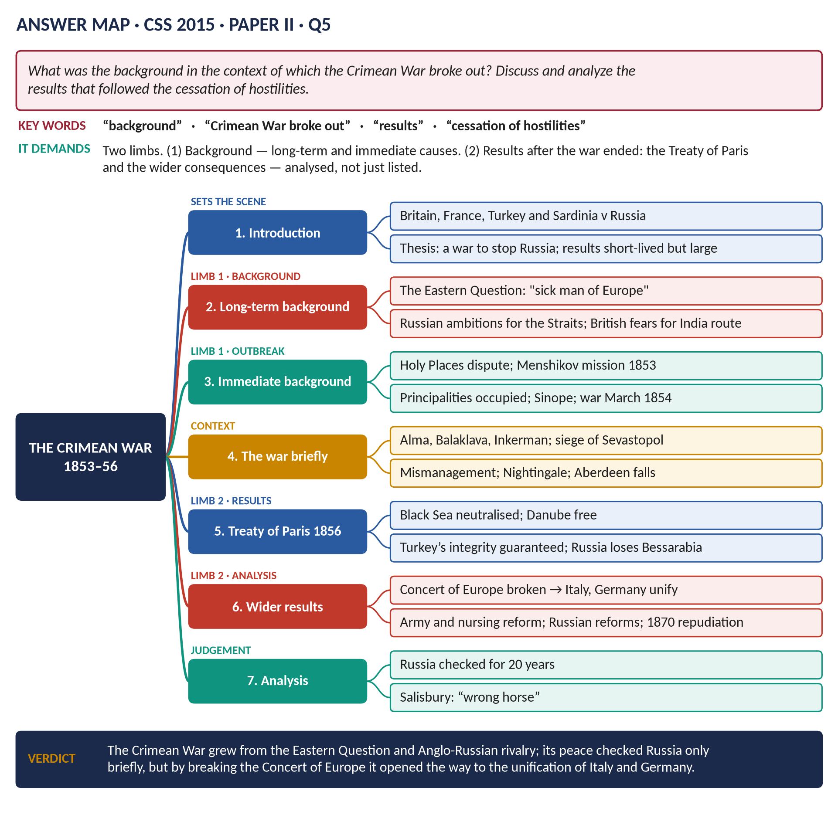
Figure 7 · The answer map for CSS 2015 · Q5 · Paper II: every branch is one heading of the answer below.
DECODING THE QUESTION
Two limbs. (1) "What was the background in the context of which the Crimean War broke out?" — the long-term background (the Eastern Question, Anglo-Russian rivalry) and the immediate events of 1852–54. (2) "Discuss and analyze the results that followed the cessation of hostilities" — the Treaty of Paris and the consequences for Russia, Turkey, Europe and Britain, analysed (were they lasting? important?). The fighting itself needs only a short section.

The model answer

Introduction
The Crimean War (1853–56) was fought by Britain, France, the Ottoman Empire and later Sardinia against Russia. It grew out of the Eastern Question — Russia's ambition to dominate the declining Turkish Empire, and Britain's determination to stop it. The war itself was notorious for mismanagement, but its results were important: the Treaty of Paris checked Russia only briefly, while the breakdown of the Concert of Europe opened the way to the unification of Italy and Germany.
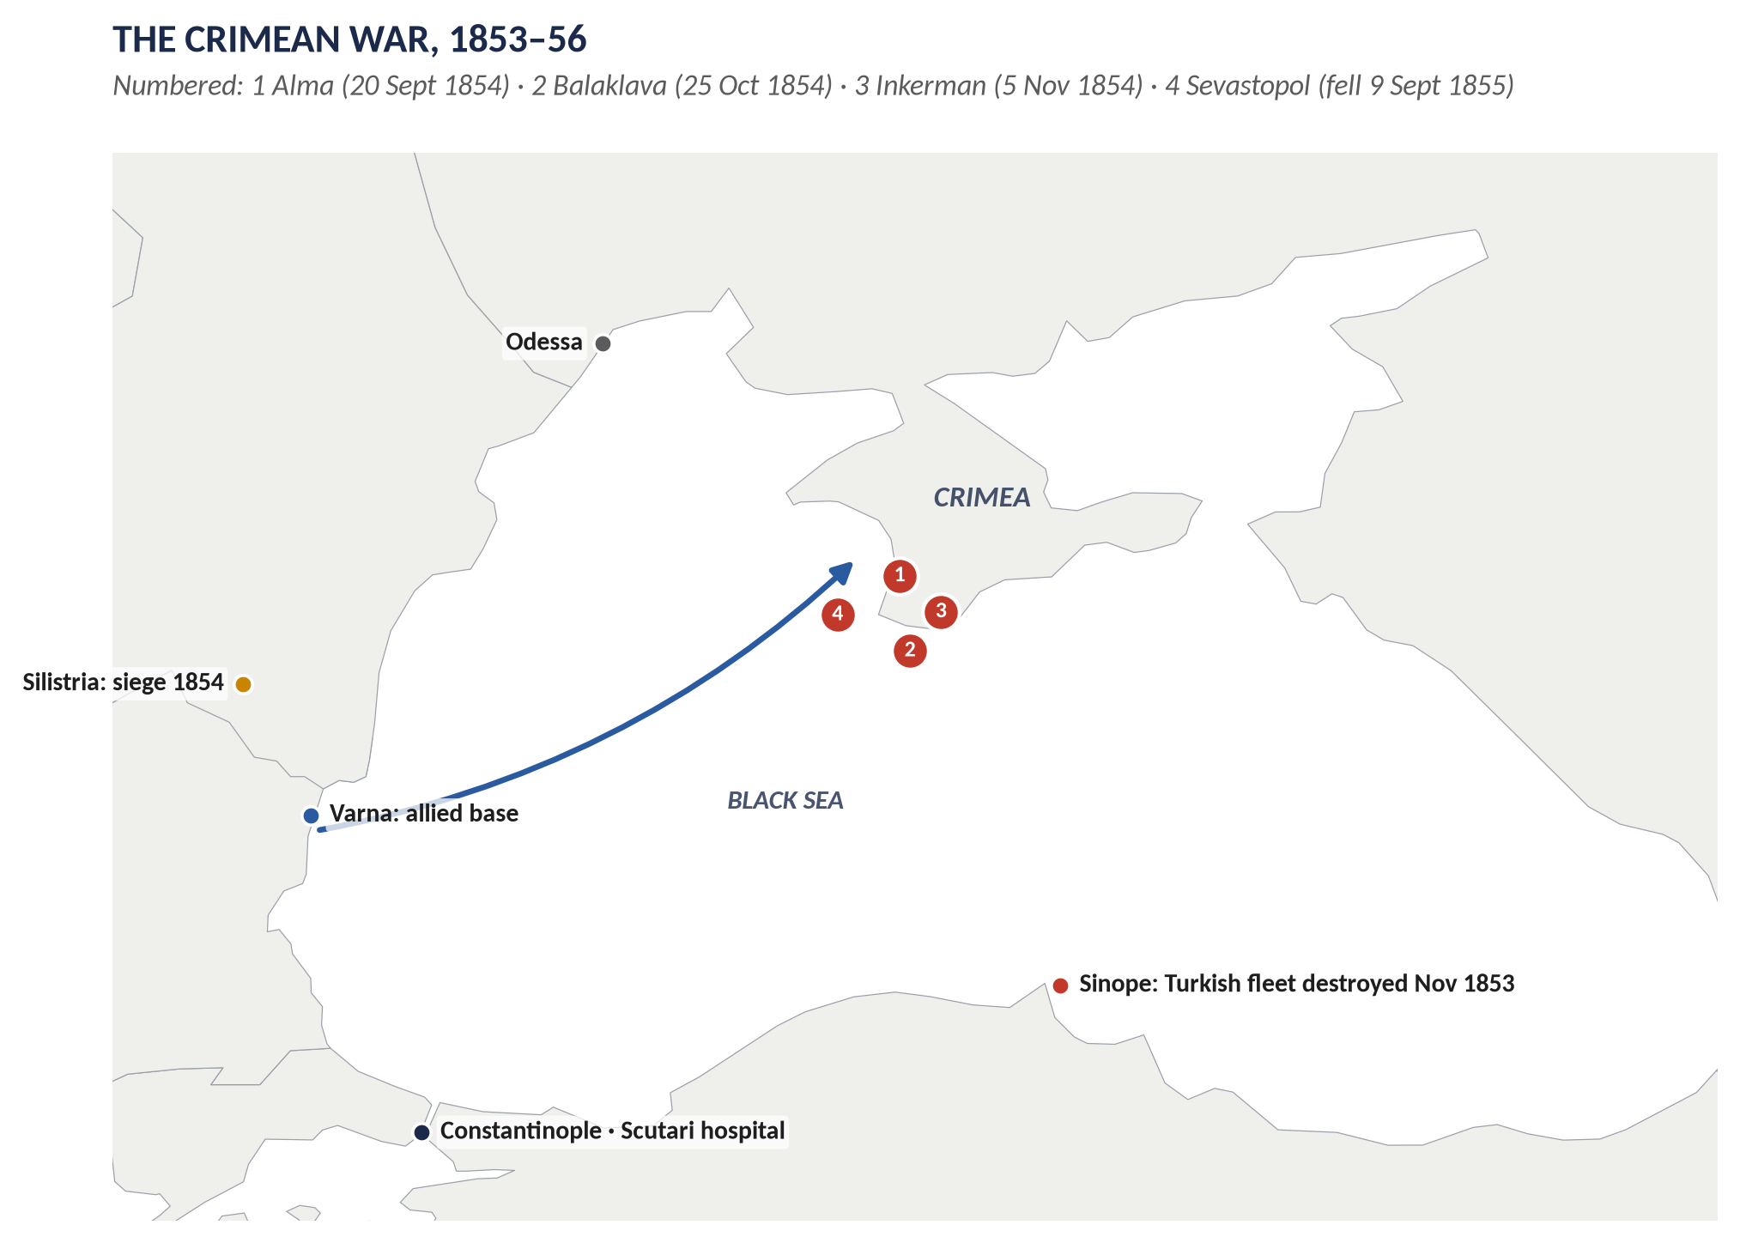
Figure 8 · The Crimean War: the Black Sea theatre.

Limb 1 · The background

(1) The long-term background

(a) The Eastern Question
The Ottoman Empire was weak and seemed near collapse. Tsar Nicholas I told the British ambassador in 1853: "We have a sick man on our hands." He proposed dividing its lands with Britain in advance; Britain refused.

(b) Russian ambitions
Russia wanted control or free use of the Straits, influence over the Sultan's Orthodox Christians (about a third of his subjects), and leadership of the Slav peoples.

(c) British fears
- A Russian fleet passing the Straits could threaten Malta, Egypt and the route to India.
- Russian domination of Turkey would upset the balance of power.
- British opinion was fiercely Russophobic: Russia was the tyrant that had crushed Poland (1831) and Hungary (1849).
- Britain's trade with Turkey was growing.

(d) French ambitions
Napoleon III, the new French emperor, wanted prestige, the support of French Catholics, and to break up the conservative alliance of Russia, Austria and Prussia that had kept France down since 1815.

(2) The immediate background, 1852–1854
1. The Holy Places (1852): Catholic and Orthodox monks quarrelled over the keys and the star of the Church of the Nativity in Bethlehem. Under French pressure the Sultan favoured the Catholics — an insult to Russia.
2. The Menshikov mission (February–May 1853): Nicholas sent Prince Menshikov to demand a treaty recognising Russia as protector of all Orthodox Christians in the empire — which would have given Russia a right to interfere everywhere. The Sultan, encouraged by the British ambassador Stratford Canning (Lord Stratford de Redcliffe), refused.
3. The Principalities (July 1853): Russian troops occupied Moldavia and Wallachia. The British and French fleets moved to the Dardanelles.
4. The Vienna Note (July 1853): the powers' compromise was accepted by Russia but rejected by Turkey.
5. War between Turkey and Russia (October 1853).
6. Sinope (30 November 1853): the Russian fleet destroyed a Turkish squadron at anchor. The British press called it a "massacre", and public opinion demanded war.
7. The allied fleets entered the Black Sea; Russia refused to leave the Principalities; Britain and France declared war on 28 March 1854.
KEY IDEA · A war of drift
The British Prime Minister, Lord Aberdeen, wanted peace, but his cabinet was divided, opinion was inflamed, and each step (moving the fleets) made retreat harder. The war was the result of mutual suspicion, miscalculation and public pressure as much as of deliberate policy.

(3) The war in brief
- The allies landed in the Crimea to capture Sevastopol, Russia's Black Sea naval base: victories at the Alma (20 Sept 1854), Balaklava (25 Oct — the Charge of the Light Brigade) and Inkerman (5 Nov).
- The terrible winter of 1854–55: about 21,000 British soldiers died in the war, about 16,000 of them from disease. The Times reporter William Howard Russell exposed the mismanagement; Florence Nightingale reformed the hospital at Scutari.
- Aberdeen fell (January 1855); Palmerston became Prime Minister.
- Sevastopol fell in September 1855. The new Tsar, Alexander II, accepted peace after Austria threatened to join the allies.

Limb 2 · The results

(4) The Treaty of Paris (30 March 1856)
1. The Black Sea neutralised: no warships or naval arsenals on its shores.
2. Russia ceded southern Bessarabia, cutting it off from the mouth of the Danube.
3. Free navigation of the Danube under an international commission.
4. Moldavia and Wallachia self-governing under Turkish rule, guaranteed by all the powers.
5. Russia gave up its claim to protect the Sultan's Christians; the Sultan promised reforms and equal rights (the Hatt-i Humayun, 1856).
6. Turkey admitted to the Concert of Europe; its independence and integrity guaranteed.
7. The Declaration of Paris: rules for war at sea; privateering abolished.

(5) The results for the Eastern Question
- Russia checked — but only for about fifteen years. In 1870, while France and Prussia were at war, Russia repudiated the Black Sea clauses; the London Conference (1871) accepted it.
- Turkey saved but not reformed: the promised reforms were not carried out; Christian revolts continued (1875–78).
- Romania: Moldavia and Wallachia elected the same prince and united (1859–61) — a new Balkan state.

(6) The results for Europe — the most important
- The Concert of Europe broke down: Russia felt betrayed by Austria, which it had saved in 1849 and which had threatened it in 1855. Russia no longer defended the settlement of 1815.
- This allowed Piedmont (Sardinia), which had joined the war to win a seat at the peace conference, to unify Italy (1859–61), and Prussia under Bismarck to unify Germany (1864–71) — both at Austria's expense, and both with Russia standing aside.
- France enjoyed a brief period as the leading power of Europe.

(7) The results for Britain
- Army reform: the scandal prepared the way for the Cardwell reforms (1868–74); the Victoria Cross was created (1856).
- Nursing and medicine: Nightingale's work founded modern nursing (the Nightingale School, 1860).
- Politics: Aberdeen's fall; Palmerston's supremacy.
- Press and opinion: the power of the press and the telegraph in war was revealed.
- Disillusion with European wars: Britain fought no European war again until 1914 — part of the background to Splendid Isolation.

(8) The results for Russia
Defeat showed Russia's backwardness; Alexander II began the Great Reforms, including the emancipation of the serfs (1861) and army reform.

(9) Analysis — was the war worth it?
- For Britain: its aims were achieved briefly; the long-term benefits were small, and Salisbury later admitted Britain had "put its money on the wrong horse" (1897).
- For Europe: the war's greatest consequences were unintended — the breakdown of the Concert and the rise of Italy and Germany, which changed the balance of power far more than the Treaty of Paris.
VERDICT · Conclusion
The Crimean War broke out because the Eastern Question set Russia's ambitions against Britain's fear for the Straits and the route to India, and because a quarrel over the Holy Places, the Menshikov mission and the destruction of the Turkish fleet at Sinope led the powers to drift into war. Its immediate result, the Treaty of Paris, checked Russia only until 1870; its real results were the collapse of the Concert of Europe, the unification of Italy and Germany, the reform of Russia, and in Britain a lasting reform of the army and of nursing.

WHY THIS ANSWER SCORES · Why this answer scores
The background is split into long-term and immediate causes, with dates · the war itself is brief · the results are organised by who was affected (the Eastern Question, Europe, Britain, Russia) and analysed (lasting? intended?) · the "wrong horse" quotation and the Concert argument show depth.

Short Note

The Treaty of Berlin (1878)
THE QUESTION · CSS 2016 · Q8(b) · Section B · short note (10 marks)
Write a short note on: Treaty of Berlin

The Treaty of Berlin (13 July 1878) was signed at the Congress of Berlin, chaired by the German Chancellor Bismarck as "honest broker". It revised the Treaty of San Stefano (3 March 1878), which Russia had imposed on defeated Turkey after the Russo-Turkish War (1877–78).
- Why a congress: San Stefano created a huge "Big Bulgaria" reaching the Aegean, which Britain and Austria-Hungary saw as a Russian satellite. Disraeli threatened war (the fleet at Constantinople; Indian troops to Malta); Salisbury's Circular demanded a revision by all the powers.
- Terms:
  - Bulgaria cut into three: a small self-governing Bulgaria (north); Eastern Rumelia (self-governing under the Sultan); Macedonia returned to Turkey.
  - Serbia, Montenegro and Romania fully independent.
  - Bosnia and Herzegovina occupied and administered by Austria-Hungary.
  - Russia kept southern Bessarabia and Kars and Batum.
  - Britain gained Cyprus (by the separate Cyprus Convention with Turkey).
- Significance: Disraeli claimed "Peace with Honour"; a European war was avoided and Russia checked. But Russia was humiliated and blamed Germany (leading to Bismarck's alliance with Austria in 1879); the Balkan peoples' wishes were ignored — Bulgaria absorbed Eastern Rumelia in 1885, Austria's annexation of Bosnia (1908) led to the Sarajevo assassination (1914).
In one line: a diplomatic triumph for Disraeli that kept the peace for a generation but planted the seeds of the First World War in the Balkans.

Answer 6 · Gladstone and Disraeli: Characters and Policies, Especially in Foreign Affairs
THE QUESTION · CSS 2015 · Q4 · Paper II · 20 marks
Analyze the characters and policies of Gladstone and Disraeli with special reference to foreign affairs.


Figure 9 · The answer map for CSS 2015 · Q4 · Paper II: every branch is one heading of the answer below.
DECODING THE QUESTION
"Analyze the characters and policies" = examine both men's personalities and both men's policies, comparing them. "With special reference to foreign affairs" = most of the policy section must be on foreign and imperial policy (the Eastern Question, empire, Egypt, South Africa); domestic policy only briefly. Link character to policy — how each man's personality shaped his foreign policy.

The model answer

Introduction
From 1868 to 1881 British politics was dominated by the rivalry of two extraordinary men: the Conservative Benjamin Disraeli and the Liberal William Ewart Gladstone. They alternated as Prime Minister (Disraeli 1868 and 1874–80; Gladstone 1868–74 and 1880–85) and disliked each other intensely. Their characters could hardly have been more different, and so were their ideas of foreign policy: Disraeli sought prestige, power and empire; Gladstone sought morality, law and the Concert of Europe. Yet in office each was often forced to act much like the other.

The characters

(1) Disraeli (1804–81)
- Background: born into a Jewish family, baptised an Anglican at 12; no public school or university; a novelist (Vivian Grey, Coningsby, Sybil) and a dandy with debts — an outsider who climbed "to the top of the greasy pole".
- Personality: witty, romantic, theatrical, charming and flattering; an opportunist who loved power and political combat.
- Beliefs: the nation, the Crown, the empire and "One Nation" — national unity across classes.
- The Queen: her favourite; he flattered her ("Everyone likes flattery; and when you come to royalty you should lay it on with a trowel"), made her Empress of India, and she made him Earl of Beaconsfield (1876).

(2) Gladstone (1809–98)
- Background: son of a rich Liverpool merchant; Eton and Oxford (a double first); a Tory, then a Peelite, then Liberal leader.
- Personality: earnest, intensely religious (a High Anglican), tireless, learned; saw politics as a moral and Christian duty; could seem self-righteous.
- Beliefs: liberty, economy, justice, the rights of nations, the public law of Europe.
- The Queen: she disliked him — "He speaks to me as if I were a public meeting."
 | Disraeli | Gladstone
Temperament | Romantic, witty, cynical | Earnest, moral, intense
Politics as | A great game | A moral duty
Key value | Prestige and power | Justice and liberty
Style in foreign affairs | Bold strokes, secret deals, threats | Public argument, law, the Concert

The policies — foreign affairs
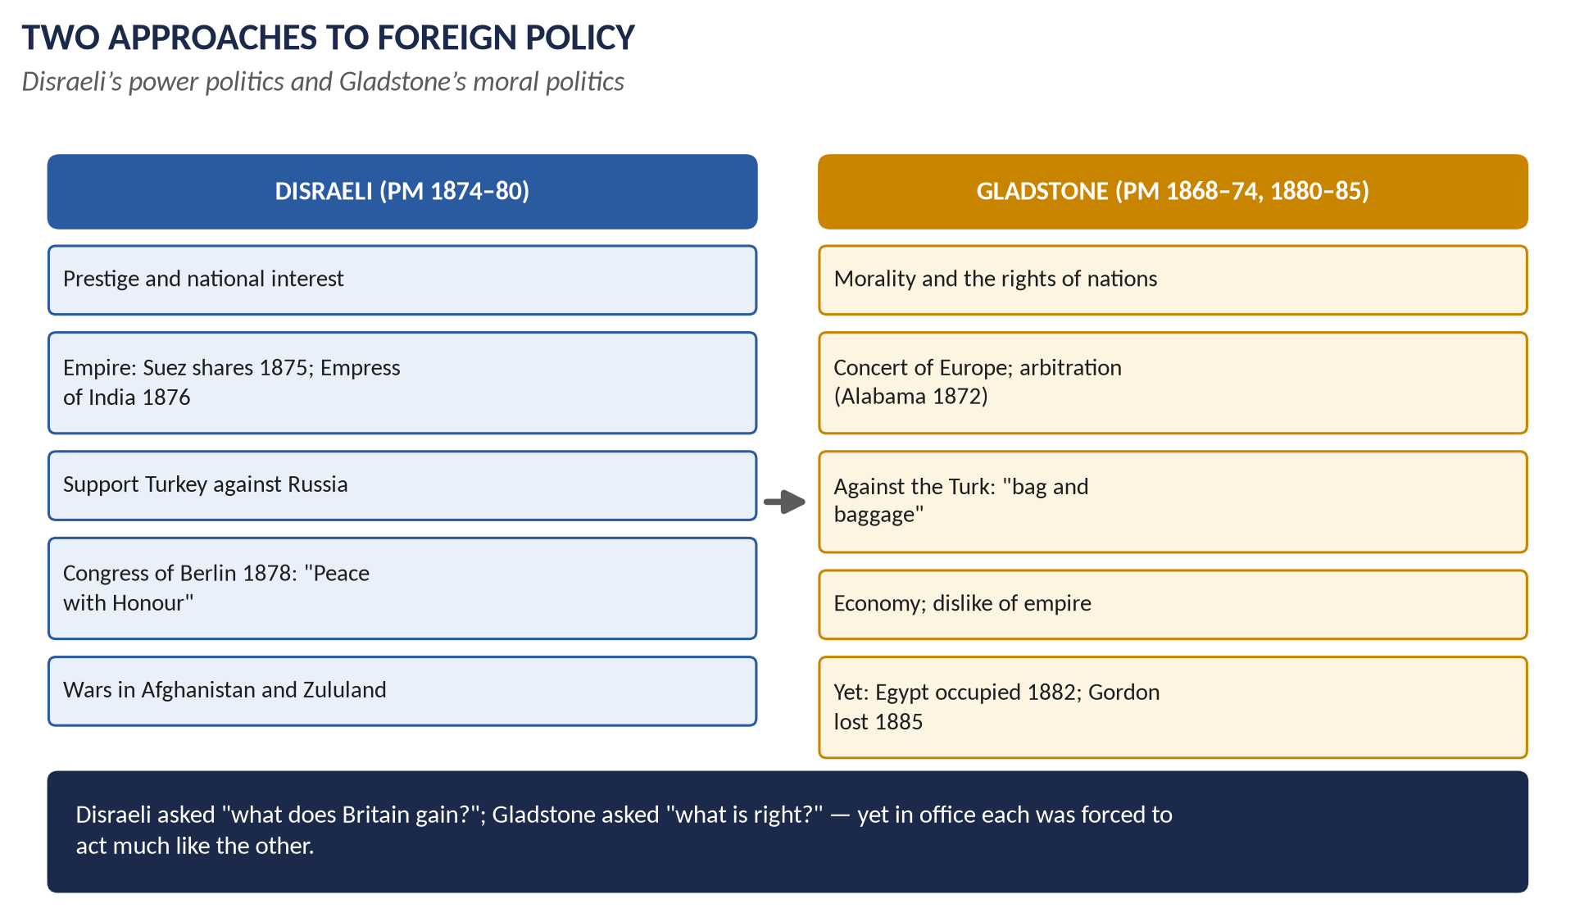
Figure 10 · Two approaches to foreign policy.

(3) Disraeli's foreign and imperial policy (1874–80)

(a) The programme
At the Crystal Palace (1872) Disraeli said the Conservatives would uphold the empire and accused the Liberals of trying to dissolve it.

(b) The Suez Canal shares (1875)
He bought the Khedive's 44 per cent of the shares for £4 million, borrowed from the Rothschilds, to secure the route to India.

(c) Empress of India (1876)
The Royal Titles Act — a symbol of imperial power aimed at India and Russia.

(d) The Eastern crisis and Berlin (1875–78)
He supported Turkey against Russia, dismissed the Bulgarian massacres as "coffee-house babble", sent the fleet to Constantinople (1878), forced Russia to submit San Stefano to a congress, and at Berlin (1878) cut back Big Bulgaria and gained Cyprus — "Peace with Honour".

(e) The forward policy
The Second Afghan War (1878–80) and the Zulu War (1879, the disaster of Isandlwana) — expensive and embarrassing. Gladstone called it "Beaconsfieldism".

(4) Gladstone's principles
In his Midlothian campaign (1879) Gladstone set out six principles: good government at home; peace; the Concert of Europe; no needless entanglements; the equal rights of all nations; foreign policy inspired by the love of freedom.

(5) Gladstone's foreign policy in practice

(a) First ministry (1868–74)
- Neutrality in the Franco-Prussian War (1870), with treaties protecting Belgium.
- Accepted Russia's repudiation of the Black Sea clauses at the London Conference (1871), insisting on the principle that treaties change only by agreement.
- The Alabama arbitration (1872): paid the USA $15.5 million — a landmark for peaceful settlement, though critics called it weak.

(b) The Bulgarian agitation (1876)
His pamphlet The Bulgarian Horrors demanded that the Turks leave Bulgaria "bag and baggage" — foreign policy as a moral crusade.

(c) Second ministry (1880–85) — principle meets reality
- South Africa: after the defeat at Majuba (1881) he gave the Transvaal self-government — principled, but seen as humiliation.
- Egypt: he bombarded Alexandria and occupied Egypt (1882, Tel-el-Kebir) — the greatest imperial expansion of the decade, by the leader who attacked imperialism.
- The Sudan: he sent Gordon to evacuate Khartoum; the relief came too late; Gordon was killed (1885).
- Penjdeh (1885): he stood firm against Russia on the Afghan frontier.

(6) Domestic policy — briefly
- Gladstone: the great reforms of 1868–74 (education, civil service, army, ballot) and 1880–85 (the franchise); Irish Home Rule (Topic 5).
- Disraeli: the Second Reform Act (1867) and the social reforms of 1874–80 (housing, public health, trade unions).

Analysis

(7) How character shaped policy
- Disraeli's romantic imagination saw Britain as a great imperial power on the world stage; his opportunism made him ready for bold strokes like Suez.
- Gladstone's religious conscience made him judge foreign policy by right and wrong; his financial mind hated costly wars.

(8) The paradox of office
Issue | Disraeli | Gladstone
Words | Empire, prestige | Morality, peace
Russia | Checked at Berlin | Checked at Penjdeh
Egypt | Bought the canal shares | Occupied the country
Wars | Afghanistan, Zululand | Egypt, Sudan

Both men served the same British interests — the route to India, the balance of power — and in office both used force and diplomacy much alike. Their difference was greater in language and spirit than in results.
VERDICT · Conclusion
Disraeli and Gladstone were opposites in character — the romantic, witty opportunist against the earnest Christian moralist — and their foreign policies reflected it: Disraeli pursued prestige, empire and power politics, Gladstone the Concert of Europe, law and the rights of nations. Yet the pressures of British interest drove both towards similar actions: Disraeli bought the Suez Canal shares, and Gladstone occupied Egypt. Their rivalry gave Victorian politics its drama and shaped the two great traditions of British foreign policy — realism and idealism.

WHY THIS ANSWER SCORES · Why this answer scores
Characters first (with a comparison table), then policies, with foreign affairs given most space as demanded · Gladstone's principles set against his practice · the link between character and policy is analysed · the paradox of office gives a sophisticated conclusion.

Answer 7 · Disraeli's Policy and "Peace with Honour"
THE QUESTION · CSS 2016 · Q5 · Section A · 20 marks
Explain the policy of Disraeli with special reference to 'Peace with Honour'.

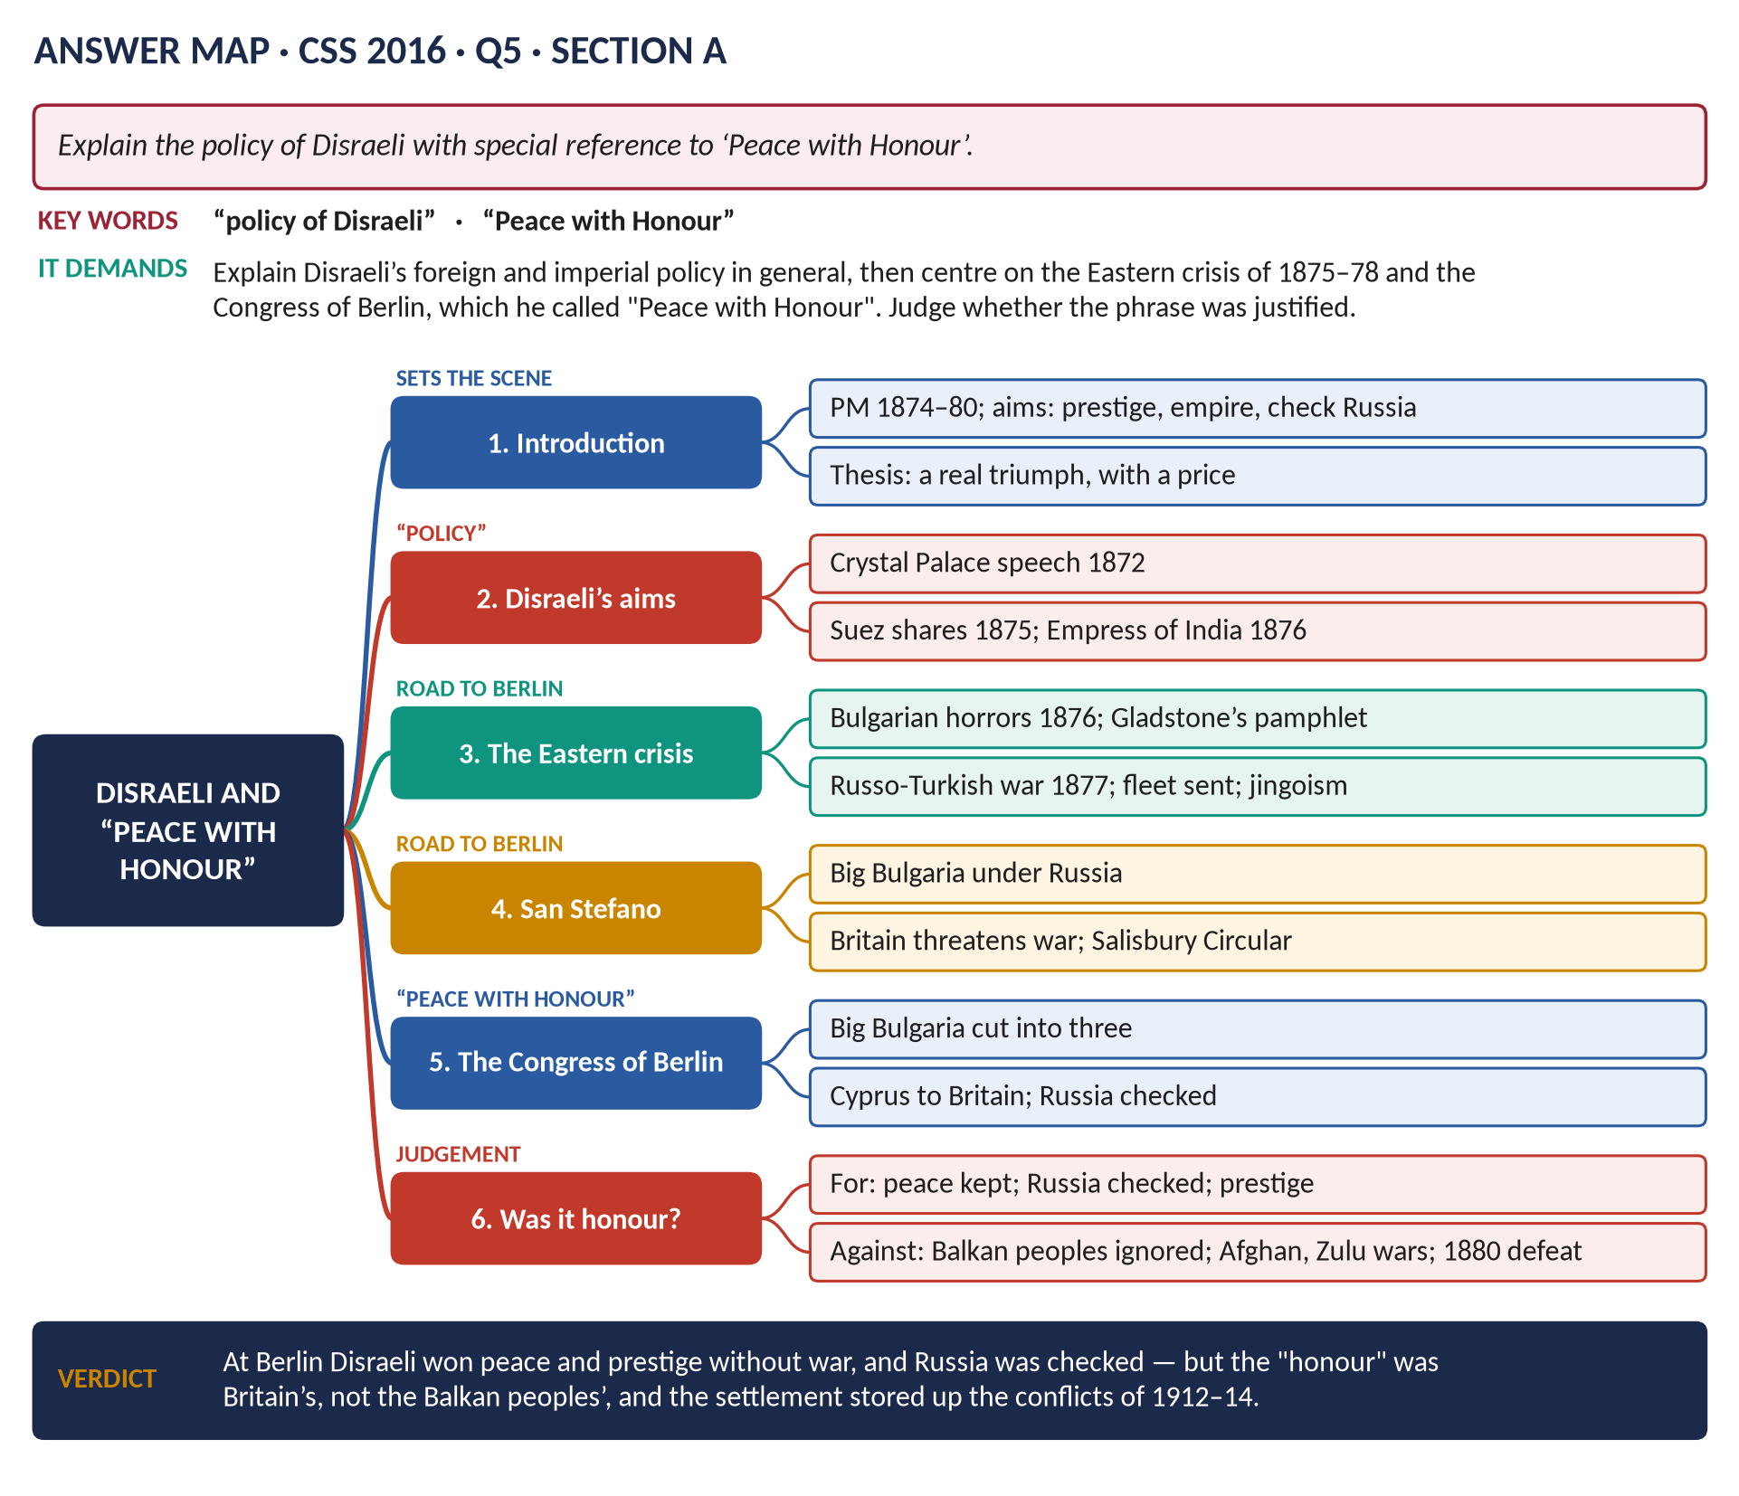
Figure 11 · The answer map for CSS 2016 · Q5 · Section A: every branch is one heading of the answer below.
DECODING THE QUESTION
"Explain the policy of Disraeli" = his policy as Prime Minister (1874–80) — mainly foreign and imperial. "With special reference to 'Peace with Honour'" = the heart of the answer is the Eastern crisis of 1875–78 and the Congress of Berlin, after which Disraeli claimed "peace with honour". Explain what happened, then judge whether the claim was justified.

The model answer

Introduction
Benjamin Disraeli, Earl of Beaconsfield, was Conservative Prime Minister from 1874 to 1880. His foreign policy aimed to restore Britain's prestige, to strengthen the empire and above all to check Russia and protect the route to India. Its high point came in July 1878, when he returned from the Congress of Berlin declaring: "I have returned from Berlin bringing peace — but a peace I hope with honour." This answer explains his policy and argues that "Peace with Honour" was a real diplomatic triumph for Britain — but one bought at the expense of the Balkan peoples and followed by less honourable wars.

(1) Disraeli's aims
- Prestige: he believed Gladstone had let Britain's influence decline (the Alabama payment, the Black Sea).
- Empire: in his Crystal Palace speech (1872) he made the empire one of the three great aims of the Conservative Party.
- Russia: the chief threat to the Straits and India.
- The Concert: he wanted Britain to be a leading voice in Europe again.

(2) Imperial measures
- The Suez Canal shares (November 1875): £4 million from the Rothschilds for 44 per cent of the shares — control of the route to India.
- The Royal Titles Act (1876): Victoria Empress of India.

(3) The Eastern crisis, 1875–77
1. 1875: revolt in Bosnia and Herzegovina.
2. 1876: a rising in Bulgaria was crushed with massacres by Turkish irregulars — the "Bulgarian horrors". Disraeli at first dismissed the reports as "coffee-house babble".
3. Gladstone's pamphlet (September 1876) roused the nation against the Turks — "bag and baggage".
4. The Constantinople Conference (December 1876) failed; the Sultan rejected reform.
5. April 1877: Russia declared war on Turkey. After the siege of Plevna, the Russians advanced to the edge of Constantinople (January 1878).

(4) Britain's response — the threat of war
- The fleet was sent through the Dardanelles to Constantinople (February 1878).
- Parliament voted £6 million for war preparations; Indian troops were moved to Malta; reserves called up.
- Public opinion was inflamed: "We don't want to fight, but by Jingo if we do…" — the birth of jingoism.

(5) San Stefano (3 March 1878)
Russia dictated peace to Turkey. The treaty created a huge "Big Bulgaria", stretching to the Aegean Sea, under Russian influence — a Russian foothold on the Mediterranean. Britain and Austria refused to accept it.

(6) Preparing the Congress
- Lord Derby, the cautious Foreign Secretary, resigned; Lord Salisbury replaced him and issued the Salisbury Circular (April 1878), demanding that the whole treaty be reviewed.
- Secret agreements: with Russia (to reduce Bulgaria), with Austria (on Bosnia), and with Turkey — the Cyprus Convention (June 1878): Britain would occupy Cyprus and defend Turkey's Asian lands against Russia.
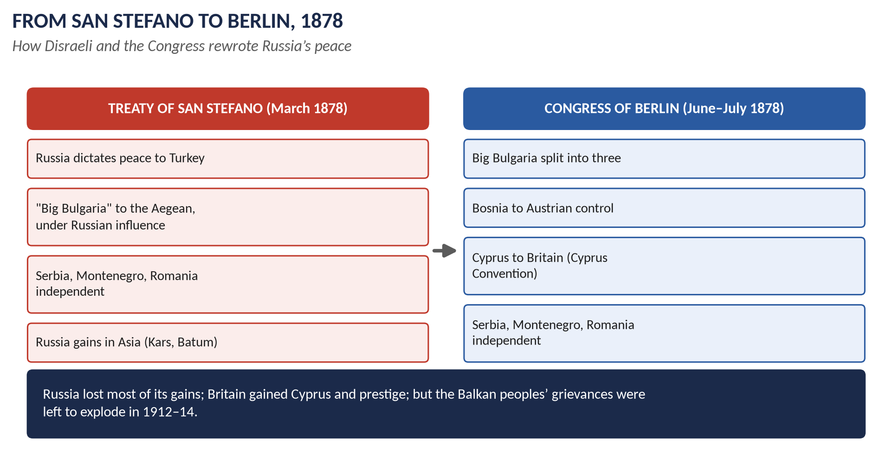
Figure 12 · From San Stefano to Berlin.

(7) The Congress of Berlin (13 June – 13 July 1878)
Chaired by Bismarck as "honest broker". Its terms:
1. Big Bulgaria divided into three — a small autonomous Bulgaria, Eastern Rumelia under Turkish rule, and Macedonia returned to Turkey. Russia lost its access to the Aegean.
2. Serbia, Montenegro and Romania independent.
3. Bosnia and Herzegovina occupied by Austria-Hungary.
4. Russia kept southern Bessarabia, Kars and Batum.
5. Britain gained Cyprus.
Bismarck said of Disraeli: "The old Jew — that is the man." Disraeli came home to cheering crowds and refused a dukedom; the Queen gave him the Garter.

(8) Was it "Peace with Honour"? — the case for
1. Peace: war with Russia was avoided.
2. Russia checked: the Russian satellite on the Aegean was prevented; the Straits and the route to India were safe.
3. Prestige: Britain was again a leading power; Disraeli dominated the Congress.
4. Cyprus: a base in the eastern Mediterranean, near Suez.
5. The Concert worked: a crisis was settled by the powers together.

(9) The case against
1. The Balkan peoples ignored: Bulgarians were divided against their will (they reunited in 1885); Bosnia was handed to Austria — the root of the 1908 crisis and the 1914 assassination at Sarajevo.
2. Turkey not reformed: Britain protected the Sultan whose troops had massacred the Bulgarians; the reforms promised for Macedonia and Armenia never came.
3. Russia humiliated: Russia blamed Germany, leading to the Dual Alliance (1879) and, later, to the division of Europe into blocs.
4. The forward policy that followed: the Afghan War (1878–80) and Zulu War (1879, Isandlwana) cost lives and money and damaged the government.
5. The voters' verdict: Gladstone's Midlothian campaign attacked "Beaconsfieldism"; the Conservatives lost the 1880 election.
VERDICT · Conclusion
Disraeli's policy aimed at prestige, empire and the containment of Russia, and at the Congress of Berlin he achieved all three without war: Big Bulgaria was broken up, Russia was kept from the Mediterranean, and Britain gained Cyprus. It was a genuine diplomatic triumph — "peace", certainly, and "honour" for Britain. But it was not honour for the Balkan peoples, whose grievances were stored up for the future, and it was followed by unnecessary wars that cost Disraeli the election of 1880.

WHY THIS ANSWER SCORES · Why this answer scores
It explains Disraeli's general policy first, then centres on 1875–78 as "special reference" requires · the sequence from Bosnia to San Stefano to Berlin is clear and dated · Berlin's terms listed · "Peace with Honour" judged with five points for and five against · a clear, balanced verdict.

Answer 8 · Splendid Isolation: Why Adopted, How Abandoned
THE QUESTION · CSS 2015 · Q7 · Paper II · 20 marks
Why did Britain adopt the Policy of Splendid Isolation from 1870 onwards in external affairs? How was this policy abandoned by the end of the 19th century? Discuss and analyze.

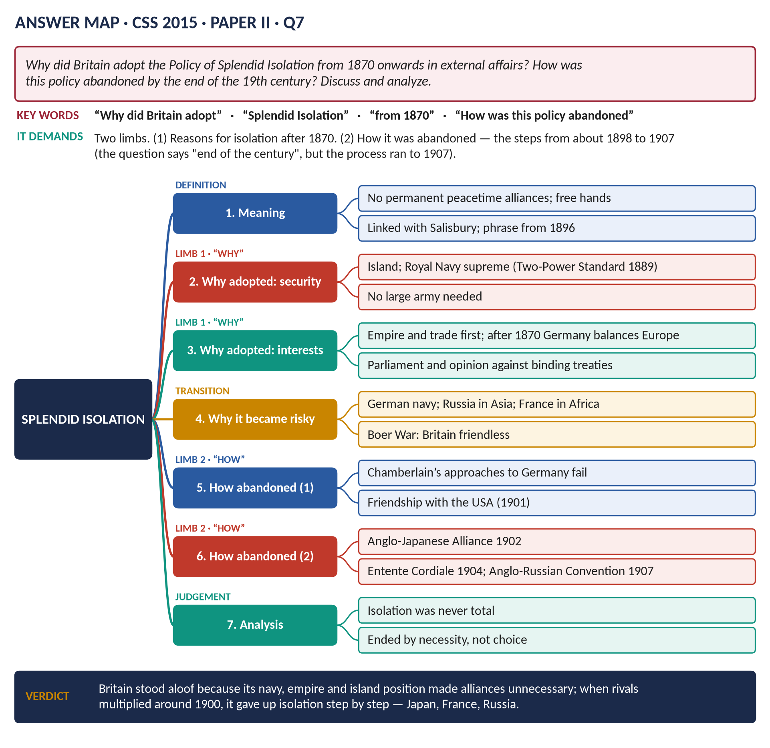
Figure 13 · The answer map for CSS 2015 · Q7 · Paper II: every branch is one heading of the answer below.
DECODING THE QUESTION
Two limbs. (1) "Why did Britain adopt the Policy of Splendid Isolation from 1870 onwards?" — the reasons. (2) "How was this policy abandoned by the end of the 19th century?" — the steps (the process began in the late 1890s and was completed by 1907 — say so). "Discuss and analyze" = explain and judge. First define Splendid Isolation clearly.

The model answer

Introduction
Splendid Isolation was the name given to Britain's policy, in the late nineteenth century, of avoiding permanent alliances with other Great Powers in peacetime, so as to keep its "free hands". It is associated above all with Lord Salisbury, Prime Minister and Foreign Secretary for most of 1885–1902. Britain adopted it because its navy, empire, wealth and island position made alliances seem unnecessary and dangerous. It abandoned it between about 1898 and 1907, when the rise of Germany and quarrels with France, Russia and the USA made isolation risky — through the Anglo-Japanese Alliance (1902), the Entente Cordiale (1904) and the Anglo-Russian Convention (1907).
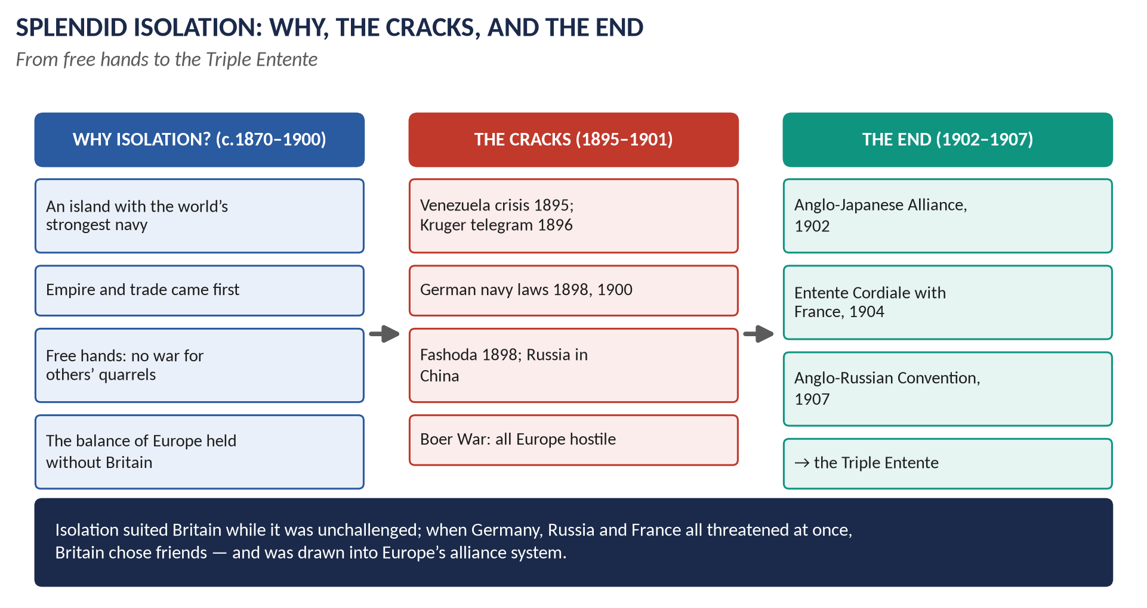
Figure 14 · Splendid Isolation: why, the cracks, and the end.

(1) What Splendid Isolation meant
- No binding peacetime alliances with Great Powers; freedom to decide each question on its merits.
- Not total isolation: Britain was active in the world, signed colonial agreements, and made limited arrangements such as the Mediterranean Agreements (1887) with Italy and Austria.
- The phrase was first used in January 1896 by the Canadian politician George Foster, and then by British ministers.
- Salisbury's image: British policy was to "float lazily downstream, occasionally putting out a diplomatic boat-hook to avoid collisions".

Limb 1 · Why Britain adopted it from 1870

(2) Security: an island and a navy
- The Channel and the Royal Navy made invasion almost impossible; Britain did not need allies to defend its own soil.
- The Naval Defence Act (1889) set the Two-Power Standard: the navy must be as strong as the next two navies combined.

(3) Global interests
- Britain's interests were world-wide: India, trade routes, colonies. A European alliance might drag Britain into continental wars over issues (like Alsace-Lorraine or the Balkans) that did not concern it.

(4) The European balance after 1870
- After the Franco-Prussian War (1870–71) and German unification, Bismarck wanted peace and kept Europe stable through his alliances — the Dual Alliance (1879), the Triple Alliance (1882), the Reinsurance Treaty (1887).
- With the balance of power maintained by others, Britain could stand aside.

(5) Economic and imperial strength
- Britain was the world's greatest trading, financial and imperial power; it felt self-sufficient.
- Money was better spent on the navy than on a large army for continental alliances.

(6) Politics and public opinion
- Parliament would not accept secret treaties binding Britain to go to war in the future. Salisbury argued that no British government could promise what a future Parliament would do.
- The Crimean War (1854–56) had shown the cost of a continental war; Britain did not fight in Europe again until 1914.

(7) Confidence
Victorian Britain believed in its own greatness; alliances seemed a sign of weakness.

Limb 2 · How the policy was abandoned

(8) Why isolation became dangerous (1890–1902)
1. Germany: after Bismarck's fall (1890), Kaiser Wilhelm II pursued Weltpolitik (world policy). The Kruger telegram (January 1896) congratulated the Boers on defeating the Jameson Raid; Tirpitz's Navy Laws (1898, 1900) began building a fleet aimed at Britain.
2. France and Russia formed an alliance (1894) — Britain's two chief colonial rivals together.
3. Russia advanced into China (Port Arthur, 1898) and threatened India through Central Asia.
4. France clashed with Britain at Fashoda (1898).
5. The USA threatened war over the Venezuela boundary (1895).
6. The Boer War (1899–1902): Europe was openly hostile; the British army's early defeats showed how thinly its forces were stretched.

(9) Step 1 · Failed approaches to Germany (1898–1901)
Joseph Chamberlain, the Colonial Secretary, publicly proposed an Anglo-German alliance (1898, 1899, 1901). Germany demanded that Britain join the Triple Alliance and believed Britain could never reach agreement with France or Russia. The talks failed — a turning point.

(10) Step 2 · Friendship with the USA
The Hay–Pauncefote Treaty (1901) let the USA build and fortify a canal across Panama; Britain reduced its Caribbean fleet — the beginning of the lasting Anglo-American friendship.

(11) Step 3 · The Anglo-Japanese Alliance (30 January 1902)
- Signed by Lord Lansdowne.
- If either power was at war with one power in the Far East, the other would stay neutral; if with two, it would join its ally.
- It checked Russia in the Far East and allowed Britain to reduce its Pacific fleet.
- Britain's first peacetime alliance with a Great Power in generations — the end of Splendid Isolation.

(12) Step 4 · The Entente Cordiale (8 April 1904)
- Prepared by Edward VII's visit to Paris (1903) and the French foreign minister Delcassé.
- France accepted British control of Egypt; Britain accepted French interests in Morocco; other colonial disputes settled.
- Not an alliance, but strengthened by the First Moroccan Crisis (1905–06) and Algeciras (1906), after which British and French military staffs began secret talks.

(13) Step 5 · The Anglo-Russian Convention (31 August 1907)
- Signed by Sir Edward Grey.
- Persia divided into spheres of influence; Afghanistan British; Tibet neutral — the end of the Great Game.
- With France and Russia already allied, the Triple Entente faced the Triple Alliance.

(14) Analysis
- Isolation was never total: the Mediterranean Agreements and colonial treaties show Britain always made arrangements when it needed them.
- Abandoned by necessity, not choice: Britain turned first to Germany; only when that failed did it settle with Japan, France and Russia — the powers that threatened its empire.
- The agreements were imperial deals: Egypt for Morocco; Persia and Afghanistan — but they gradually became European commitments against Germany.
VERDICT · Conclusion
Britain adopted Splendid Isolation after 1870 because its navy, island position, worldwide empire and economic strength made alliances unnecessary, and because Bismarck's Europe kept its own balance. When Germany's rise, the Franco-Russian alliance, colonial clashes and the Boer War left Britain dangerously alone, it abandoned isolation in stages — failing with Germany, then allying with Japan (1902) and reaching understandings with France (1904) and Russia (1907). By 1907 Britain was part of the Triple Entente, and the road that would lead it into the First World War had been opened.

WHY THIS ANSWER SCORES · Why this answer scores
Definition first, including that isolation was not total · Limb 1 gives six reasons, grouped · Limb 2 explains why isolation became dangerous and then the steps of abandonment, dated · the answer notes that the process ran past 1900 — showing precise knowledge · a genuine analysis section.

Answer 9 · How Britain Halted Splendid Isolation — Its Positive and Negative Aspects
THE QUESTION · CSS 2018 · Q6 · Section B · 20 marks
How did Britain put a halt to the Policy of Splendid Isolation? What were its positive and negative aspects?

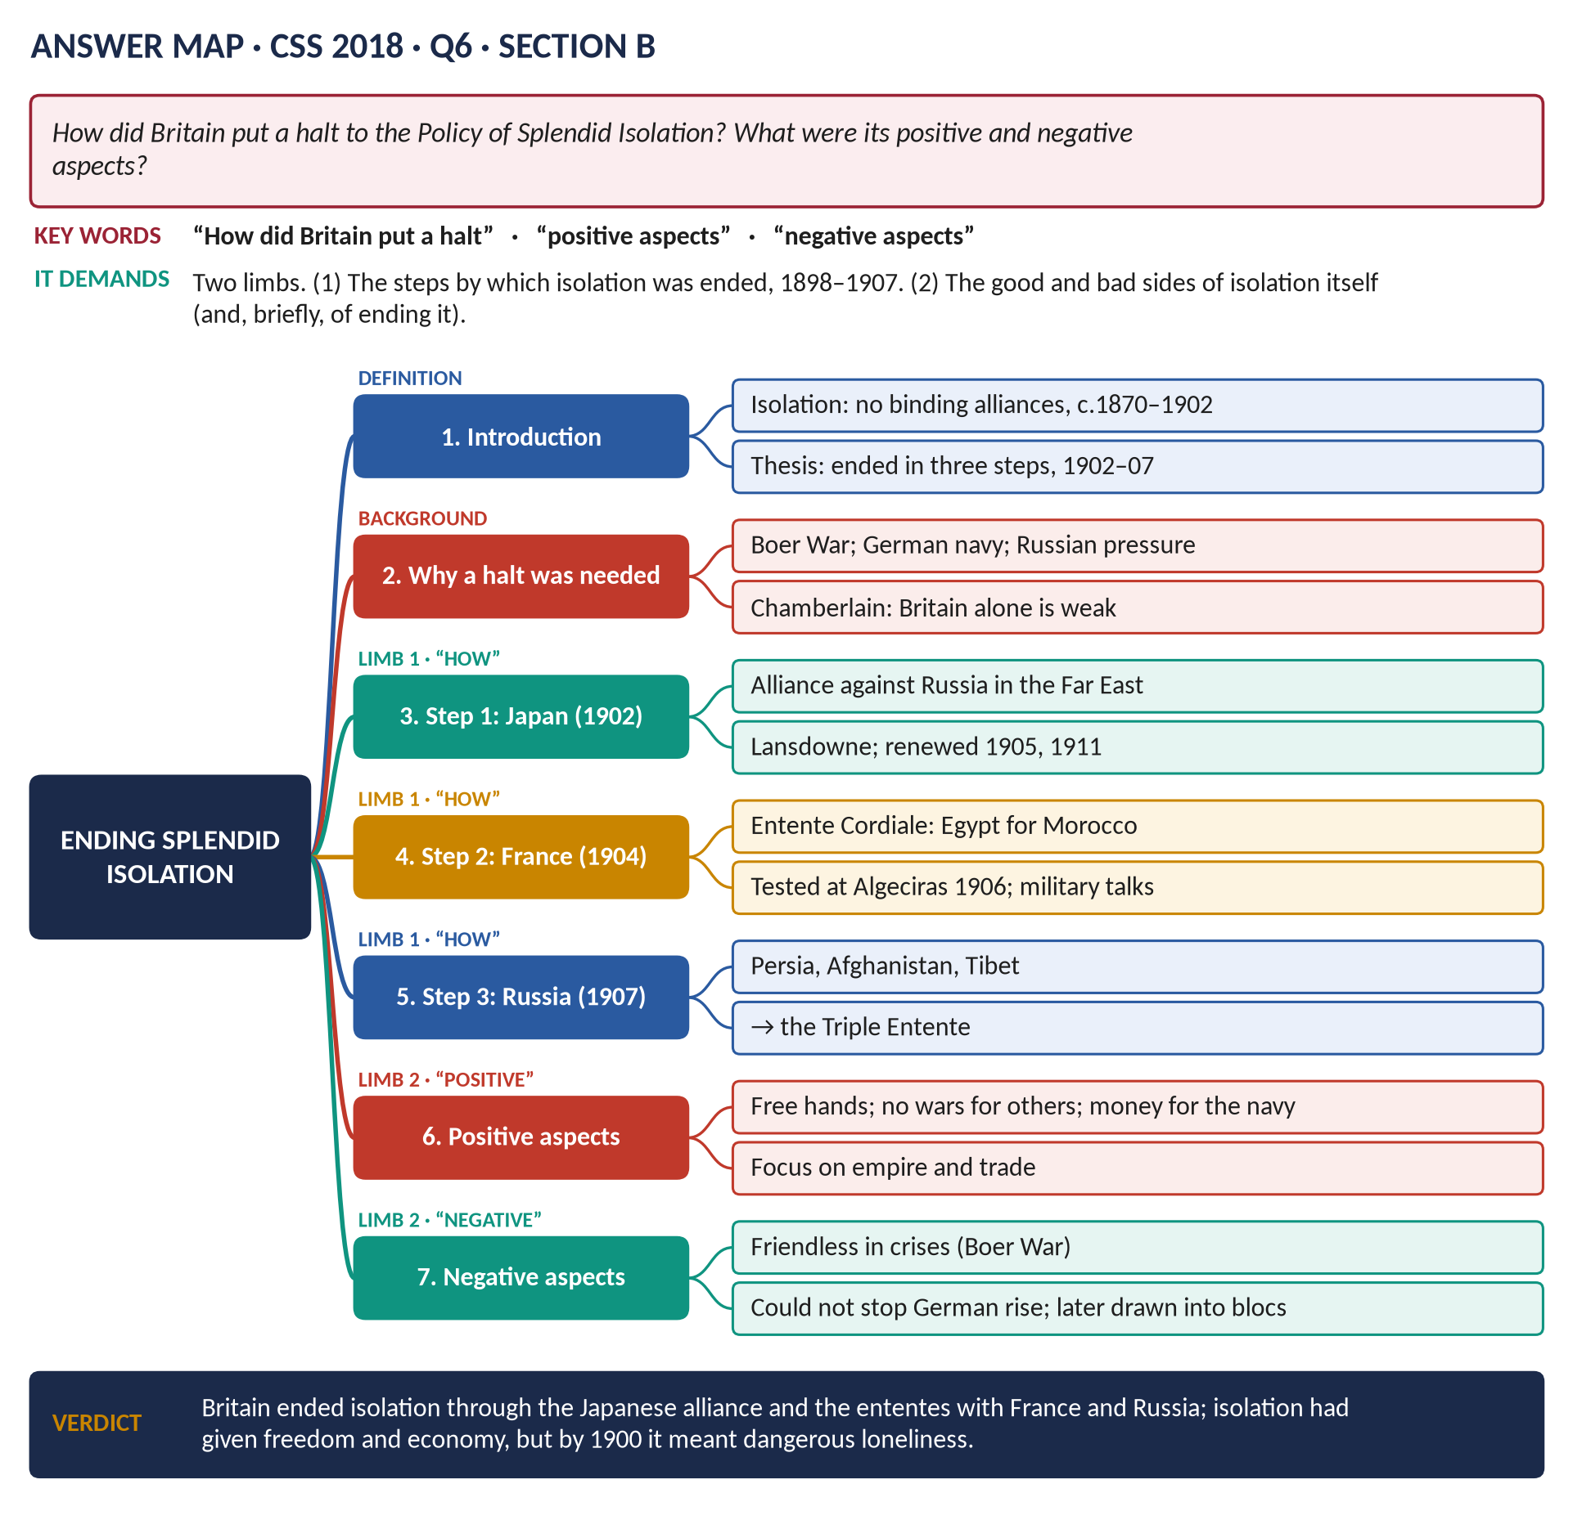
Figure 15 · The answer map for CSS 2018 · Q6 · Section B: every branch is one heading of the answer below.
DECODING THE QUESTION
Two limbs. (1) "How did Britain put a halt to the Policy of Splendid Isolation?" — the steps of ending it (1898–1907). (2) "What were its positive and negative aspects?" — "its" means the policy of isolation itself: what was good and what was bad about it. Adding a short note on the positive and negative results of ending it shows depth.

The model answer

Introduction
Splendid Isolation — Britain's avoidance of permanent peacetime alliances with the Great Powers, associated with Lord Salisbury — lasted roughly from 1870 to 1902. Britain put a halt to it in three main steps: the Anglo-Japanese Alliance (1902), the Entente Cordiale with France (1904) and the Anglo-Russian Convention (1907). The policy had real advantages — freedom, economy and peace — but by the 1890s its disadvantages — loneliness in a hostile world — had become dangerous.

Limb 1 · How Britain put a halt to isolation

(1) The pressures that forced a change
- The Boer War (1899–1902): Britain fought for three years with almost every European power openly hostile; its army was stretched and humiliated in "Black Week" (1899).
- Germany: the Kruger telegram (1896) and the Navy Laws of 1898 and 1900 — a battle fleet in the North Sea could only be aimed at Britain.
- Russia in China and Central Asia; France in Africa (Fashoda, 1898); both allied since 1894.
- Over-stretch: the navy could not be strong everywhere at once.

(2) The first attempt: Germany (1898–1901)
Joseph Chamberlain proposed an Anglo-German alliance three times. Germany wanted Britain to join the Triple Alliance without concessions and did not believe Britain could come to terms with France or Russia. The failure pushed Britain elsewhere.

(3) Step 1 · The Anglo-Japanese Alliance (1902)
- Signed on 30 January 1902 by Lord Lansdowne and the Japanese ambassador Hayashi.
- Terms: each would stay neutral if the other fought one power in the Far East, and help if it fought two.
- Why: to check Russia in China and Korea, and to let Britain bring warships home.
- Result: Japan defeated Russia in 1904–05 without French intervention; the alliance was renewed (1905, 1911).

(4) Step 2 · The Entente Cordiale (1904)
- Prepared by King Edward VII's visit to Paris (May 1903) and Delcassé's diplomacy.
- Signed on 8 April 1904: Egypt for Britain, Morocco for France; Newfoundland, Siam and the New Hebrides settled.
- Tested by Germany in the First Moroccan Crisis (1905, the Kaiser at Tangier); at Algeciras (1906) Britain stood by France; secret Anglo-French military conversations began.

(5) Step 3 · The Anglo-Russian Convention (1907)
- Signed on 31 August 1907 by Sir Edward Grey.
- Persia divided into Russian, British and neutral zones; Afghanistan a British sphere; Tibet neutral.
- Result: the Great Game ended; with France already allied to Russia, the Triple Entente was formed.

(6) Also: friendship with the USA
The Hay–Pauncefote Treaty (1901) removed the last serious quarrel with the United States.
Year | Agreement | What it did
1901 | Hay–Pauncefote | Friendship with the USA
1902 | Anglo-Japanese Alliance | Ally in the Far East against Russia
1904 | Entente Cordiale | Colonial settlement with France
1907 | Anglo-Russian Convention | Colonial settlement with Russia → Triple Entente

Limb 2 · Positive and negative aspects of Splendid Isolation

(7) Positive aspects
1. Freedom of action ("free hands"): Britain could judge each crisis by its own interests, without being bound by allies.
2. Peace: Britain avoided every European war between 1856 and 1914 — the Franco-Prussian, Austro-Prussian and Russo-Turkish wars.
3. Economy: no need for a large continental army; money went to the navy (the Two-Power Standard, 1889), which protected trade and empire.
4. Focus on empire and trade: Britain built the largest empire in history.
5. Bargaining power: others courted Britain; it could make limited deals when needed (Mediterranean Agreements, 1887; Heligoland–Zanzibar, 1890).
6. Democratic control: no secret treaties committing a future Parliament to war.

(8) Negative aspects
1. No friends in a crisis: in 1895–1902 Britain quarrelled with the USA (Venezuela), Germany (Kruger telegram), France (Fashoda) and Russia (China) — and in the Boer War stood alone against a hostile Europe.
2. No influence over the alliance systems: Britain could not shape or restrain the Triple Alliance or the Franco-Russian alliance.
3. Could not deter Germany: isolation allowed Germany to believe it could build a navy against Britain without consequence.
4. Over-stretch: a world-wide empire defended alone strained the navy and the army.
5. Complacency: it hid Britain's relative decline as the USA and Germany overtook it industrially.

(9) Positive and negative results of ending it
- Positive: security in the Far East and Mediterranean; colonial disputes with France and Russia settled; the navy concentrated in the North Sea.
- Negative: Britain drawn into rival blocs; Germany felt encircled; secret military talks created a moral obligation to France — part of the road to 1914.
VERDICT · Conclusion
Britain put a halt to Splendid Isolation in stages — after failing to ally with Germany, it allied with Japan in 1902 and reached ententes with France in 1904 and Russia in 1907. Isolation had served Britain well while it was unchallenged, giving it freedom, peace and economy; but by the 1890s it left Britain friendless among rising rivals. Ending it brought security but at the price of entanglement in the alliance systems that led to the First World War.

WHY THIS ANSWER SCORES · Why this answer scores
Limb 1 explains the pressures and then the steps, dated and summarised in a table · Limb 2 lists six positive and five negative aspects of the policy itself, as "its" requires · a brief section on the results of ending it adds depth · a balanced verdict.

Answer 10 · Splendid Isolation: Why It Began, and Was It Right?
THE QUESTION · CSS 2023 · Q4 · Section A · 20 marks
Why did Britain initiate the Policy of Splendid Isolation? What is your personal opinion whether it was a right step in the right direction or proved detrimental?

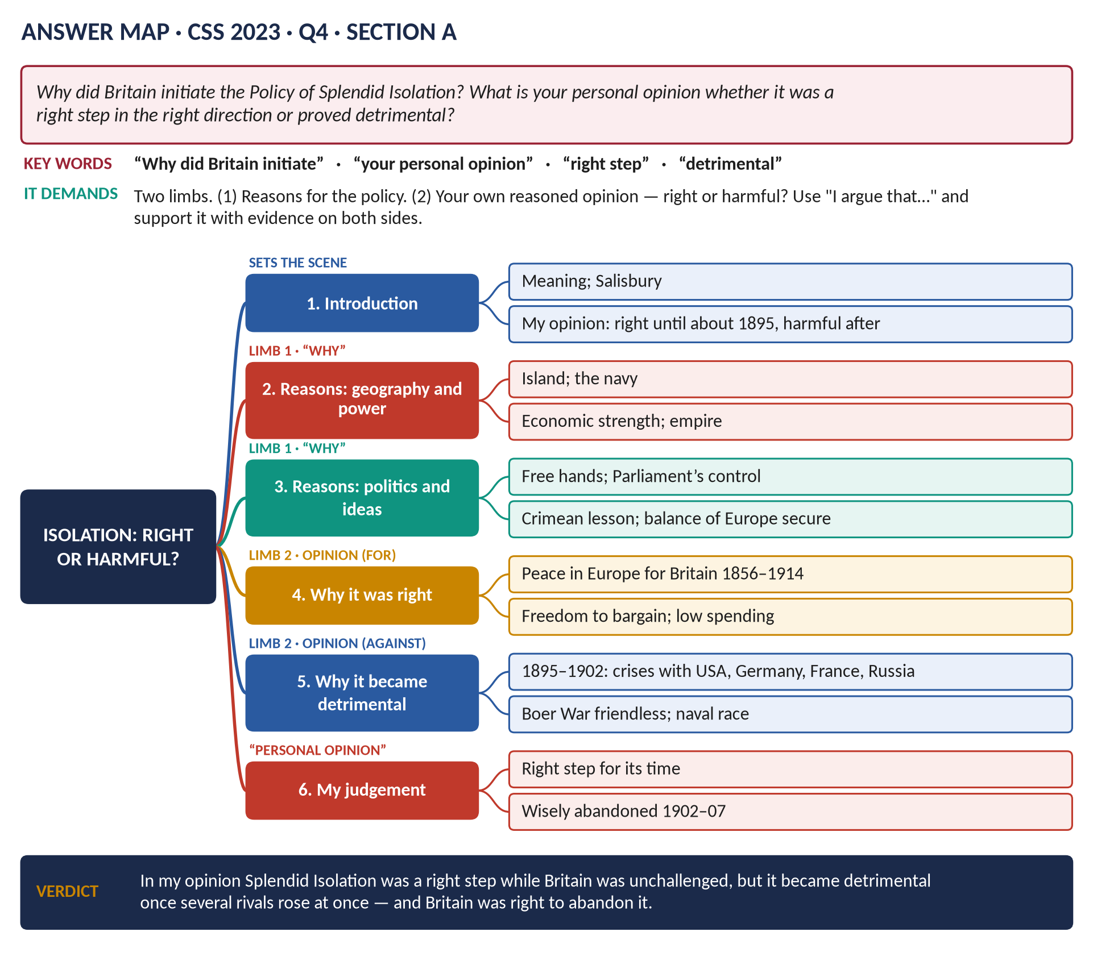
Figure 16 · The answer map for CSS 2023 · Q4 · Section A: every branch is one heading of the answer below.
DECODING THE QUESTION
Two limbs. (1) "Why did Britain initiate the Policy of Splendid Isolation?" — the reasons. (2) "What is your personal opinion whether it was a right step in the right direction or proved detrimental?" — you must give your own view, clearly, in the first person ("In my opinion…", "I argue…"), and support it with evidence, while fairly considering the other side. A sensible opinion often distinguishes periods.

The model answer

Introduction
Splendid Isolation was Britain's policy, from about 1870 to 1902, of refusing to join permanent peacetime alliances with other Great Powers. It is linked with Lord Salisbury, who described Britain's diplomacy as "floating lazily downstream". Britain initiated it because its navy, island position, empire and wealth made alliances seem unnecessary, and because the European balance was kept by others. In my opinion, isolation was a right step while Britain was unchallenged — until about 1895 — but it became detrimental once several rivals rose at the same time; Britain was then right to abandon it.

Limb 1 · Why Britain initiated the policy

(1) Geography and sea power
- An island: protected by the Channel from invasion.
- The Royal Navy: the largest in the world; the Two-Power Standard (1889) kept it as strong as the next two navies combined.

(2) Economic and imperial strength
- Britain was the world's leading trading and financial power, with the largest empire. Its interests lay across the oceans, not on the continent.
- A large army for continental alliances would be costly and unnecessary.

(3) The European situation after 1870
- German unification (1871) created a new balance. Bismarck wanted peace and built alliances that kept Europe stable.
- Britain could leave the continental balance to others and intervene only if it was seriously threatened.

(4) Freedom of action
- British governments wanted "free hands" to deal with each issue according to British interests.
- Parliament and public opinion disliked secret treaties that might commit Britain to war in the future — Salisbury argued no government could bind a future Parliament.

(5) Lessons of the past
- The Crimean War (1854–56), costly and of doubtful value, discouraged involvement in continental quarrels.
- The Congress system after 1815 had shown the danger of being tied to autocratic allies.

Limb 2 · My opinion — right step or detrimental?

(6) Why I think it was a right step (c.1870–1895)
1. It kept Britain out of wars: Britain fought no European war from 1856 to 1914, while France, Austria, Prussia, Russia and Turkey fought several.
2. It suited Britain's strength: with the strongest navy and economy, Britain did not need allies to be safe.
3. It saved money: resources went into the navy and the empire, which grew enormously.
4. It kept Britain's freedom: Britain could bargain with all sides and make limited agreements when useful — the Mediterranean Agreements (1887) and the Heligoland–Zanzibar Treaty (1890).
5. It respected Parliament: no secret commitments to war.

(7) Why I think it became detrimental (c.1895–1902)
1. Friendless in crises: in a few years Britain quarrelled with the USA (Venezuela, 1895), Germany (the Kruger telegram, 1896), France (Fashoda, 1898) and Russia (China). During the Boer War (1899–1902) Europe was openly hostile.
2. Rival alliances: the Franco-Russian alliance (1894) and the Triple Alliance left Britain outside both blocs, with no influence over either.
3. The German navy: the Navy Laws of 1898 and 1900 threatened Britain's naval supremacy; alone, Britain could not both match Germany in the North Sea and guard its empire.
4. Over-stretch and relative decline: the USA and Germany had overtaken British industry; Britain could no longer afford to stand alone.

(8) Considering the opposite view
- Some argue that isolation was always a mistake — it let the continental alliances form without Britain and encouraged Germany's ambitions. But in the 1870s and 1880s Britain faced no serious threat, and alliances would only have dragged it into others' quarrels.
- Others argue that ending isolation was the real mistake, because the ententes drew Britain into the First World War. But by 1902 isolation could no longer protect the empire, and the agreements with Japan, France and Russia were mainly colonial settlements that solved real dangers.

(9) My judgement
Period | My assessment
c.1870–1895 | A right step: peace, freedom, economy; Britain unchallenged
c.1895–1902 | Detrimental: several rivals at once; the Boer War; the German navy
1902–1907 | Rightly abandoned: Japan, France, Russia — though at the cost of entanglement

VERDICT · Conclusion
Britain initiated Splendid Isolation because its island position, naval supremacy, empire and wealth made alliances unnecessary, and because Bismarck's Europe kept its own balance. In my opinion, it was a right step in the right direction for as long as those conditions lasted: it kept Britain at peace, free and prosperous. But by the late 1890s, faced with a hostile Europe, a German navy and an over-stretched empire, it had become detrimental, and Britain was right to abandon it for the alliance with Japan and the ententes with France and Russia.

WHY THIS ANSWER SCORES · Why this answer scores
Limb 1 gives grouped reasons · Limb 2 gives a clear personal opinion in the first person, as the question demands, supported with evidence · it considers the opposite view fairly · a period-by-period table makes the judgement precise · the conclusion restates the opinion confidently.

Part Two — The Past MCQs, Solved

CSS 2024 · MCQ 2
The British colony of Singapore was established as a trading post along which important maritime route?
(A) Suez Canal | (B) Strait of Malacca | (C) Cape of Good Hope | (D) None of these

REMEMBER · Answer: B. Strait of Malacca
Singapore was founded in 1819 by Sir Stamford Raffles as a trading post on the Strait of Malacca — the narrow sea route between the Indian Ocean and the South China Sea.

CSS 2024 · MCQ 3
The “Scramble for Africa” refers to the period of intense European colonial expansion in Africa during which centuries?
(A) 18th and 19th | (B) 17th and 18th | (C) 19th and 20th | (D) None of these

REMEMBER · Answer: C. 19th and 20th centuries
The Scramble for Africa ran from about 1881 to 1914 — so it covers the 19th and 20th centuries. By 1914 Europeans controlled about 90 per cent of Africa.

CSS 2024 · MCQ 17
The early Victorian Anglo-Russian rivalry known as the “Great Game” was:
(A) The Boer War | (B) The Civil War | (C) The Crimean War | (D) None of these

REMEMBER · Answer: D. None of these — it was a wider geopolitical rivalry in Central Asia
The Great Game was the long Anglo-Russian rivalry for influence in Central Asia (Afghanistan, Persia, Tibet), c.1830–1907 — not the Boer War, the Civil War or the Crimean War. So the key is "None of these".

CSS 2026 · MCQ 17
The Crimean War was fought by Britain against:
(A) Russia | (B) France | (C) The Ottoman Empire | (D) None of these

REMEMBER · Answer: A. Russia
Britain (with France, the Ottoman Empire and Sardinia) fought the Crimean War (1853–56) against Russia.

Part Three — Five Predicted Questions, with Outlines
WHAT THE EXAMINER HAS ASKED · Why these five
They cover large parts of syllabus Heads IX–X that have not yet been set as full questions — and the MCQs of 2024 show the examiner has begun to test the empire.

Predicted 1 · "Compare the foreign policies of Castlereagh and Canning."
- Introduction: both Tories under Liverpool; both defended British interests; different styles.
- Castlereagh: Vienna settlement; Quadruple Alliance; congresses; State Paper 1820; worked quietly inside the Concert.
- Canning: broke with the Congress system (Verona 1822); Latin America recognised; Portugal 1826; Greece and Navarino 1827; appeal to public opinion.
- Continuity: non-intervention in others' internal affairs; balance of power; trade.
- Verdict: a difference of method and tone more than of aims.

Predicted 2 · "Discuss the causes of the Scramble for Africa and Britain's role in it."
- Causes: economic (raw materials, markets), strategic (Egypt, Suez, the Cape), rivalry and prestige (Germany, France, Italy), technology (steamships, quinine, Maxim gun), ideas (missionaries, Social Darwinism).
- Berlin Conference 1884–85.
- Britain's role: Egypt 1882; Sudan (Gordon 1885; Omdurman 1898); Nigeria, Gold Coast; Kenya, Uganda; Rhodes and Rhodesia; Fashoda 1898; Boer War 1899–1902.
- Verdict: Britain gained the largest and richest share, driven mainly by the route to India (Robinson and Gallagher).

Predicted 3 · "Examine the causes and consequences of the Boer War (1899–1902)."
- Causes: gold on the Rand (1886); the Uitlanders; Kruger; Rhodes and the Jameson Raid (1895–96); the Kruger telegram; Milner and Chamberlain's pressure.
- Course: Black Week; sieges (Ladysmith, Kimberley, Mafeking); Roberts and Kitchener; guerrilla war; concentration camps.
- Consequences: Vereeniging 1902; Union of South Africa 1910; ~22,000 British dead, £200m; army reform (Haldane); national efficiency; the end of Splendid Isolation.

Predicted 4 · "Discuss the causes and results of the Indian Mutiny of 1857."
- Causes: political (Dalhousie's annexations, Doctrine of Lapse, Awadh), religious (fear of conversion; the cartridges), economic (land revenue), military (sepoy grievances).
- Course: Meerut (10 May 1857); Delhi and Bahadur Shah; Lucknow; Cawnpore; recapture of Delhi.
- Results: Government of India Act 1858 — Crown rule, Secretary of State, Viceroy; the Queen's Proclamation; army reorganised; the end of the Mughals; racial distrust; roots of Indian nationalism.

Predicted 5 · "Trace British policy towards Egypt and the Sudan from 1875 to 1904."
- 1875 Suez shares; 1876 Dual Control; 1882 Urabi revolt, Alexandria, Tel-el-Kebir, occupation.
- Cromer's rule (1883–1907); the Mahdi; Gordon (1885); the Sudan abandoned.
- Reconquest: Kitchener, Omdurman 1898; Fashoda 1898; Anglo-Egyptian condominium (1899).
- 1904 Entente Cordiale: France accepts British Egypt.
- Verdict: the route to India turned a financial interest into a lasting occupation (to 1956).

